

**School of Art and Creative Technologies**

**M.Sc.** **Data Analytics and Technologies**

**University of Bolton**

**DEEP LEARNING APPLICATION OF FORENSIC LINGUISTICS IN AUDIO INVESTIGATION**

Prepared by Praise Chukwunalu Young

Student ID: 2209538



**May 2024**

**Abstract**

This research proposes a model that will analyse speech signals and gather distinctive features which it uses to recognise a speaker and tell speakers apart. This system solely served to distinguish between speakers via features from their voices or speech using concepts of deep learning (DL). Using the above mentioned, the model sought to determine how well the ANN model can detect the presence or absence of a person in a particular scene (considering the presence of environmental noises) using features from voice evidence such as pitch, tone etc. The model is built using python language, librosa, tensorflow, matplotlib sound file libraries, which are part of the more extensive scikit library used for specific applications of audio analysis. The model receives the sound files from the dataset sourced primarily from various individuals using stratified probability sampling method. It analyses the audio files' converting them to spectrograms from WAV format and return us the efficiency of the system, which is the intended Outcome. The model utilises several visualisation tools such as graphs, tables, plots, to explain the results. The model achieved an efficiency rate of 91%, which goes to show the efficacy of deep learning techniques in leveraging forensic linguistics for audio investigation.

**Keywords:** Crime investigation, Deep learning, Forensic linguistics, ANN, Neural Networks, Audio data, Waveform, Spectrogram, Python programming.

**Declaration**

I hereby declare that this thesis represents my own work which has been done after registration for the degree of Master of science at the University of Bolton and has not been previously included in a thesis or dissertation submitted to this or any other institution for a degree, diploma, or other qualifications. All sources used in this project have been cited and referenced.

**Signature: Praise C. Young**

**Date: 16th May, 2024.**

**Acknowledgement**

Completing this dissertation has been both a learning and an arduous journey, marked by numerous challenges and intense demands. Overcoming these obstacles required immense effort, and the process of learning was profound and continuous. Through it all, I've come to deeply believe in the transformative power of unwavering dedication and a relentless pursuit of knowledge.

I express eternal gratitude to the Almighty for granting me the strength and resilience needed to embark on and complete this substantial endeavour. His constant presence served as my wellspring of inspiration and assurance, empowering me to persevere even in the most daunting moments.

I owe a debt of thanks to my diligent supervisor, Ibtisam Mogul, whose expertise and constructive feedback were invaluable in refining this dissertation. Her keen insights not only elevated the quality of my work but also nurtured my academic development.

Special appreciation is extended to my mentor, Dr. Celestine Iwendi, whose unwavering support and encouragement have been instrumental throughout my Master's program. His belief in my abilities provided unwavering support on this journey and I do not take it for granted. My gratitude also goes to Dr. Anchal Garg and Dr. Pradeep Hewage for their dedicated commitment to student growth.

To my beloved family, particularly my parents, Comrade and Comrade Mrs. I.C. Young, I am filled with so much gratitude for their unwavering support and encouragement. Their guidance and fearless nurturing of my dreams have been invaluable and has been my beacon of hope in trying moments. My siblings – Special, Nuel, Prosper, Daniel, and Miracle – have provided boundless love and support, serving as my pillars of strength.

I'm indebted to my best friend, Dennis Ekara Mfah, whose support was crucial in navigating this Master’s degree journey. His positive influence served as a guiding light, spurring me toward this significant academic milestone. Gratitude also extends to my friends and classmates - Damilare Adeola, Olajuwon Yakub, Uchenna Victor Moses, Kelly Okondu, Collins, Chris, Joshua, David, and a host of others too many to count for their camaraderie and encouragement.

Finally, I extend my thanks to all who contributed to this research and everyone who played a role, directly or indirectly, in the success of this program. Your support has been invaluable, and I am truly grateful.

Table of Contents

CHAPTER 1. INTRODUCTION 13

1.0 Introduction 13

1.1 Background and Context 13

1.2 Crime detection and prevention 14

1.3 Crime Investigation 15

1.3.1. Traditional Approaches to Crime Investigation 16

1.3.2. The Role of Machine Learning (ML) and Deep Learning (DL) in Crime Investigation 17

**1.4 Speaker, Speech, and Voice Recognition** 18

1.5 Native Language Influence Detection 19

1.6 Problem Statement 21

1.7 Research Aims and Objectives 22

1.8 Research Questions 22

1.9 Hypothesis 23

1.10 Relevance and Importance of the Research 23

1.11 Scope and Limitations of Study 23

1.12 Thesis Organisation 25

CHAPTER 2: LITERATURE REVIEW 26

2.1 Introduction 26

2.2 A Brief History of Forensic Linguistics in Crime Investigation 26

2.2.1 A Brief History of Deep Learning Application to Forensic Linguistics in Crime Investigation 27

2.3 An Empirical Review of Relevant Literatures 29

2.4 Summary 42

CHAPTER 3: METHODOLOGY 43

3.1 Research design 44

3.2 Model Architecture design 46

3.3 Proposed Workflow 46

3.4 Methods and Sources 48

3.5 Selected Methodology 50

3.5.1 Model selection 51

3.5.1.3 Librosa Library 52

3.5.1.4 Matplotlib 52

3.5.1.5 Artificial Neural Networks (ANNs) 53

3.5.1.6 MFCC 54

3.5.2. Sample and Sampling Techniques 54

3.6 Instrument for Data Collection 55

3.7 Evaluation and Metrics 55

3.7.1.2 Precision 56

3.7.1.3 Recall 56

3.7.1.4 F1-score 56

3.7.1.5 ROC-AUC 57

**3.7.2 Comparison and Analysis** 57

3.8 Ethical Considerations 57

3.9 Summary 58

CHAPTER 4: ANALYSIS, IMPLEMENTATION AND RESULTS 60

4.1 Exploratory Data Analysis (EDA)/Data Preprocessing 60

4.2 Data Cleaning 61

4.3 Data Conversion 62

4.4 Visualisation of Data 62

4.4.1 Waveform 63

4.4.2 Spectrogram 64

4.5 Feature Engineering 67

4.6 Building the Audio Model 70

4.6.1 Data Splitting 70

4.6.2 Model Training and Evaluation 73

4.7 Computing the FPR, TPR and ROC-AUC Curve for the Models 84

4.8 Summary 87

CHAPTER 5: DISCUSSION OF RESULTS 89

5.1 Introduction 89

5.2 Analysis of Model Performance 89

5.2.1 Model Accuracy. 90

5.2.2 Model Efficiency. 90

5.2.3 Robustness (Noise Handling) 90

5.2.4 Feature Extraction. 91

5.2.5 Model Complexity. 91

5.2.6 Real-time Processing. 91

5.3 Comparison between metrics and results 91

CHAPTER 6: SUMMARY, CONCLUSION, AND FUTURE WORK 95

6.1 Summary of Findings 95

6.2 Addressing the Research Questions 95

6.3 Theoretical and Practical Contributions 96

6.3.1 Theoretical contribution 96

6.3.2 Practical contributions 96

6.4 Conclusion 97

6.5 Model Limitations and Future Research 98

6.5.1 Limitations 98

6.5.2 Future works 98

REFERENCES 100

APPENDICES 110

**tABLE of Figures**

Fig 1.1 Word cloud analysis of crime investigation keywords 12

[Fig. 1.2 Scheme of a typical voice recognition system (Tymchenko, et.al., 2020) 17](#_Toc143889593)

Fig. 3.1 Research design approaches 44

Fig. 3.2 Research Design for CI using DL 45

Fig. 3.3 Proposed Workflow 46

Fig. 3.4 Methodology. Adapted from Babu, et. al. (2021) 50

Fig. 3.5 Python programming libraries. 54

Fig. 3.6 Linguistic Analysis Tools 54

Fig. 3.7 Recording and visualisation tools 57

Fig. 4.1: Importing python libraries and dataset 61

Fig. 4.2: Checking the data class 64

Fig. 4.3 Importing the wav file 65

Fig. 4.4 Waveplot sample of the ground truth voice using the sound ‘Group’. 65

Fig. 4.5 Converting the wav file to spectrogram 64

Fig. 4.6 Spectrogram showing frequency distribution of sounds of the word ‘Attract’ 65

Fig. 4.7 Spectrogram showing frequency distribution of sounds of the word ‘Busy’. 65

Fig. 4.8 Spectrogram showing frequency distribution of sounds of the word ‘Scared’ 66

Figs 4.9: Loading and extracting features from audio using MFCCs 68

Fig. 4.10 MFCC Features in the word ‘class’- Ground truth data 69

Fig. 4.11 MFCC Features in the word class- Noise data 69

Fig. 4.12 Installing resampy to improve dataset quality 69

Fig. 4.13 Converting Extracted Features to Dataframe 70

Fig. 4.14 Extracted Features Data frame 70

Fig. 4.15 Method of preparing the dataset for splitting 71

Fig. 4.16 X/feature variables 74

Fig. 4.17 Y/Label variables 75

Fig. 4.18 Splitting the dataset 75

Fig. 4.19 Converting string labels to binary labels. 75

Fig. 4.20 Importing relevant model building libraries 76

Figs. 4.21 Defining and training the deep learning model 76

Figs. 4.22 Plotting the DL model’s architecture. 78

Figs. 4.23 Plotting the neurons using the Artificial Neural Network Architecture 79

Figs. 4.24 Plotting the neurons in the ANN Architecture (Hidden layers and dropout) 80

Fig. 4.25 Fitting and Training the model 80

Fig. 4.27 Plotting the training and validation loss for the ANN model 81

Fig. 4.28 Plotting the training and validation accuracy for the ANN model 82

Fig. 4.29 Model Evaluation using Decision Tree 83

Fig. 4.30 Model Evaluation using Random Forest 83

**Fig. 4.31 Model Evaluation and classification report using Naïve Bayes**…………………………….83

**Fig. 4.32 Model Evaluation and classification report using SVM**………………………………………..84

Fig. 4.33 Roc_auc for Decision Tree 89

Fig. 4.34 Roc_auc for Random Forest and Naïve Bayes 90

Fig. 4.35 Roc_auc for Support Vector Machine 90

Fig. 4.36 Roc_auc for the ANN model 90

Fig. 4.37 Computing the Roc_auc curve for the classification models 91

Fig. 4.38 Roc_auc curve for the classification models 91

**List of Tables**

Table 2.1. Tabular Review of Literatures 36

Table 5. 1: Comparing the metrics used in this study 92

**Table 5. 2:** **Comparing the models using the AUC rate …………………………………………………92**

Table 6.1: Answering the Research Questions 95

Table A.1:  Comparing the findings of this model with previous models 110

**Table A.2: Project Timeline………….……………………………………………………………………………..110**

**LIST OF ABBREVIATIONS**

**AE Auto Encoder**

**AI Artificial Intelligence**

**ANN Artificial Neural Network**

**ASR Automatic Speech Recognition**

**AUC Area Under Curve**

**CI Crime Investigation**

**CNN Convolutional Neural Network**

**CRBT Cochrane Risk of Bias tool**

**DL Deep Learning**

**DNN Deep Neural Network**

**DT Decision Tree**

**EDA Exploratory Data Analysis**

**FL Forensic Linguistics**

**FL-IDS Federated Learning-based Intrusion Detection System**

**FN False Negative**

**FP False Positive**

**GCN Graph Convolutional Network**

**IoT Internet of Things**

**KNN K-Nearest Neighbour**

**LIWC Linguistic Inquiry and Word Count**

**LSTM Long Short-Term Memory**

**ML Machine Learning**

**NB Naïve Bayes**

**NLID Native Language Influence Detection**

**NN Neural Network**

**QDA Quadratic Discriminant Analysis**

**ROC Receiver Operating Characteristics**

**RNN Recurrent Neural Network**

**SNs Suicide Notes**

**SVM Support Vector Machine**

**TN True Negative**

**TP True Positive**

## **CHAPTER 1. INTRODUCTION**

## **1.0 Introduction**

Forensic linguistics (FL) is the application of Linguistics, the science that studies human language, to forensic problems (Ashraf, 2023). A forensic linguist studies dialect, grammar, sentence construction, phonetics and other linguistic areas to determine authenticity and ensure correct interpretation (Coulthard, et.al 2007). Drawing on what we know about a forensic linguist, we can confidently say that in this era of technological advancement a forensic linguist can provide expert witness evidence that can help the investigators or the triers of fact. This experimental study seeks to create a model to classify speakers from the frequency domain representation of speech recordings, review literature on this concept, then using different metrics, assess the performance of the deep learning model in detecting a voice among voices.

## **1.1 Background and Context**

The importance of forensics in criminal investigation can never be over emphasised. Albeit the application of deep learning in the field of audio Forensic investigation of crime is one that has hardly been investigated or explored. First off, let us look at what deep learning is. Deep learning (DL) is a subset of machine learning, which is essentially a neural network with three or more layers (Nickson, et.al. 2019). These neural networks attempt to simulate the behaviour of the human brain, allowing it to “learn” from large amounts of data (Nickson, et.al. 2019). With the increase in the rate of crime due to technological and internet advancements, a study on audio crime detection is necessary to prevent an increase in crime rate. Several studies exist, showing numerous ways to investigate and detect different types of crime based on deep learning and machine learning. However, not many have investigated audio crimes and malicious features such as voice modulation efficiently. Most investigations on crime have concentrated on textual analysis, while audio crime analysis is still in its infancy. In this research, a model will be proposed to investigate and ascertain the perpetrator of a crime with no video evidence but just audio by classifying speakers voices from the frequency domain. Formulated on Artificial Neural Networks (ANNs), a dataset containing audio words and phrases will be considered to train the model. To increase its accuracy and robustness, we will enhance the dataset by mixing the raw audio file with several noises related to the real environment. Figure 1.1 below shows the word cloud analysis of audio crime investigation.

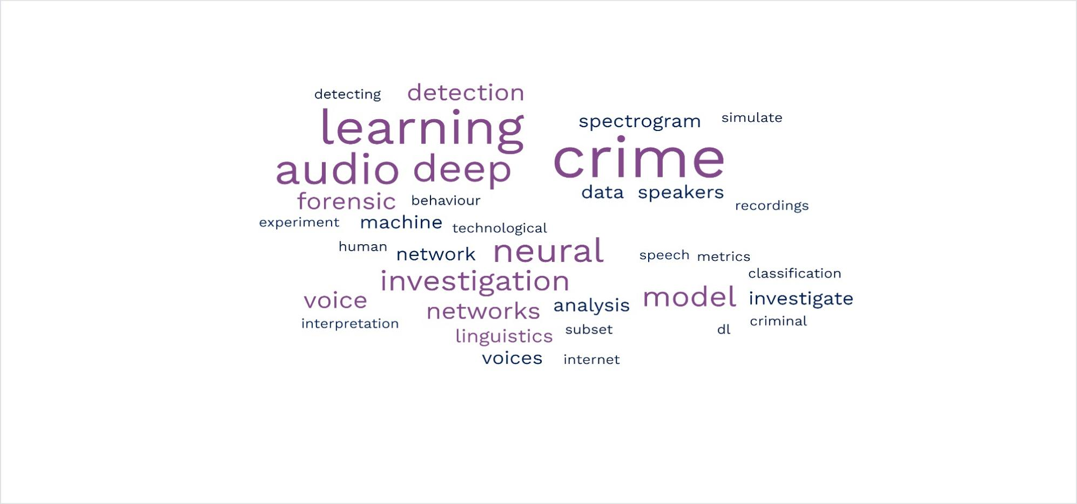

## **Fig 1.1. Word cloud analysis of crime investigation keywords**

## **1.2 Crime detection and prevention**

With the increase in economic crises, unemployment, drug usage, and retrogression, it is no surprise that the rate of crime has also increased. This has also necessitated the need for better and more accurate means of detecting and investigating these crimes. In the case of crime investigation, there are two key approaches: crime detection and crime prevention. Crime detection aims to proactively nip criminal activities in the bud, thereby preventing their growth and execution. On the other hand, crime prevention comprises strategies and measures that seek to reduce the risk of crimes occurring, and their potential harmful effects on individuals and society, including fear of crime, by intervening to influence their multiple causes. Effective crime detection and prevention requires actors in the justice system to collaborate with those in other sectors to address the root causes of criminal activities and avert conflict, violence and human rights abuses. Concerning crime and violence, this means that it is necessary to move from punitive measures to evidence-based prevention that reduces levels of violence (United Nations Office on Drugs and Crime [UNODC], n.d.).

Just as the crime choice of most offenders is influenced by the offender’s need to maximise reward while minimising risk, an effective Crime Investigation System (CIS) should not only possess the ability to efficiently detect instances of crime but also maximise reward while minimising risk i.e. exhibit cost-effectiveness (college of policing, 2024). By emphasising the significance of both prevention and detection, researchers and practitioners could devise robust systems and strategies to effectively combat crime while maintaining a balance between detection accuracy and cost-effectiveness.

## **1.3 Crime Investigation**

To maintain justice and fairness in a society, it is important that investigation is carried out correctly and properly. Criminal investigation is a multifaceted problem-solving challenge (Abdullah, et.al., 2020). It is even more multifaceted when the crime being investigated contain only audio evidence.  This complicated process of criminal identification demands high deep learning analysis and forensic skills in order to make proper insightful and analytical decisions. However, very few can earn such interpretative skills which results in a low number of proficient criminal investigators. Therefore, a lack of enough audio crime investigator is often evident (Abdullah, et.al., 2020). Hence, the need for a more straightforward model that can detect a voice even in a pool of noise/other voices.

## **1.3.1. Traditional Approaches to Crime Investigation**

In the field of crime investigation, traditional methodologies were predominantly characterised by manual procedures and rule-based systems. For example, traditional methodologies to detect and nip criminal elements in the bud include mobilizing the community by encouraging the establishment of neighbourhood watches, requesting that citizens ensure informal social control over one another, enforce civil laws in a particular area more tightly if they get the feeling that the security situation in that area is deteriorating, concentrating attention on those people and circumstances that account for a disproportionate share of a problem (e.g., repeat offenders, repeat victims, repeat locations), etc. Additionally, traditional forensic analysis methods such as Chromatography, spectroscopy, hair and fibre analysis, and serology (such as DNA examination) and examination of questionable documents were used for crime investigation. However, this has not been found to significantly deter or pre-empt the rise of crime in a region (Pande et.al, 2016). One reason for this can be said to be the fact that these methodologies were constrained by their reliance on explicit rules, rendering them less adaptable to evolving and sophisticated criminal tactics. Moreover, as criminal activities grew in complexity and generated larger datasets, traditional methods encountered difficulties in efficiently processing and analysing the vast amounts of data necessary for accurate crime investigation. While these techniques laid the groundwork for crime prevention and investigation, they were limited in their ability to keep pace with the continually evolving landscape of criminal behaviour (Wickramanayake et al., 2020).

## **1.3.2. The Role of Machine Learning (ML) and Deep Learning (DL) in Crime Investigation**

The introduction of Artificial Intelligence (AI) has significantly transformed crime investigation in various sectors by significantly enhancing accuracy, speed, and adaptability. Through advanced ML and DL algorithms, AI systems can analyse vast volumes of data in real-time, swiftly detecting anomalies that traditional methods may miss. This proactive approach enables law enforcement agencies to promptly and more accurately detect criminals and criminal activities, thereby enhancing investigation and ensuring public safety. Furthermore, with AI's continuous learning capabilities, Investigators can use machine learning to teach their systems how to recognize elements of crimes from sources like social media or surveillance footage alongside detecting new criminal tactics, thereby reducing false positives and enhancing the overall effectiveness of crime prevention efforts (Raaijmakers, 2019). By integrating AI, the law enforcement sector has elevated its crime prevention capabilities to an unprecedented level, safeguarding communities, trust, and societal well-being (Wickramanayake et al., 2020).

In the context of audio crime investigation, digital forensic analysis has proven to be a key field used in combating different crime ranging from text, video and even audio crime. Digital forensics helps investigators piece together evidence and determine the timeline of events in a crime. It is mainly made up of network forensics and memory/disk analysis. By analysing information found on disks and through networks, investigators can learn about other potential conspirators in the crime. This could help them track down these individuals and stop them before another crime is committed (Horan and Saiedian, 2021).

Traditionally, predictive models could be developed using expert rules, which are based on the knowledge and insights of crime experts. However, these rule-based models require manual tuning and continuous human supervision. In the end, these models end up most times with low rate of accuracy and high false positive and negative rate (Steyerberg et al, 2010). Alternatively, ML techniques offer a promising approach (Wickramanayake et al., 2020). By leveraging ML techniques, researchers can identify sound patterns and classify voices with a higher likelihood of being a crime culprit. ML and DL techniques involve building models based on sets of examples for prediction. These models typically take the form of parametric functions, allowing them to estimate the likelihood of a voice to match that of an audio evidence based on linguistic features.

By harnessing ML and DL learning algorithms, researchers and practitioners in the field of crime investigation can enhance efficiency and effectiveness, leading to improved crime investigation performance and reduced reliance on manual rule development and maintenance.

### **1.4 Speaker, Speech, and Voice Recognition**

Speaker recognition refers to the process of identifying the speaker based on distinctive features captured from his speech (Mohammed and Mustapha, 2022). While speech recognition, also known as automatic speech recognition (ASR), is a capability which enables a computer or program to recognise and process human speech into a machine-readable format (GitHub, n.d.). Speech recognition is widely regarded as one of the most intricate fields in computer science, encompassing elements of linguistics, mathematics, and statistics. A speech recognition system comprises several key components: speech input, feature extraction, feature vectors, a decoder, and word output. The decoder utilises acoustic models, a pronunciation dictionary, and language models to generate the correct output (IBM, n.d.). Voice recognition is the ability of a machine or program to identify an individual user’s voice (Xu, et.al. 2023). As communicating with a computer is faster using voice rather than using a keyboard, people will prefer such a system. Communication among human beings is dominated by spoken language, therefore it is natural for people to expect voice interfaces with computers (Prasad, 2015; Yumpu, 2019).

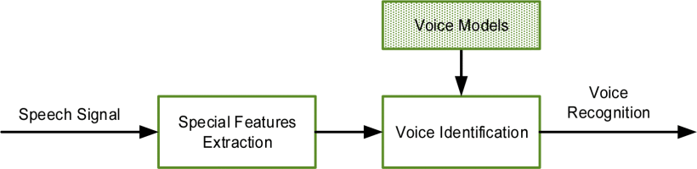

## **Fig. 1.2: Scheme of a typical voice recognition system (Tymchenko, et.al., 2020)**

## **1.5 Native Language Influence Detection**

According to publications.aston.ac.uk (n.d), a rising area of interest in sociolinguistic profiling with significant potential to influence law enforcement practices is native language influence detection (NLID) (Dras & Malmasi, 2015; Grant, 2008; Koppel, Schler, & Zigdon, 2005; Li, 2013; Malmasi, 2016; Tetreault, Blanchard, & Cahill, 2013). NLID aims to identify an author's native language, or L1, based on their writing in a second language, or L2 (publications.aston.ac.uk). The native language has a big influence on the way someone thinks. Studies have shown that language defines the way someone thinks, and a foreign language user will think in their native language and translate it to the second language. This entire process includes mistakes in choosing words and differences in sentence structure because they translate their thoughts from their native language, which has different rules in the second language. Research has demonstrated the feasibility of detecting native language influence, a capability leveraged by forensic linguists to identify traces of other languages in an anonymous author's second language. This method is effective in discerning between closely related languages, particularly those with linguistic, geographical, or cultural proximity. Moreover, it proves valuable even with concise texts, such as those encountered in forensic scenarios. Additionally, prior studies (Perkins, 2013) have illustrated its resilience against attempts by authors to conceal their linguistic origins. Thomason (2001) in publications.aston.ac.uk, opines that as multilingualism is becoming increasingly prevalent and there are now more multilingual than monolingual speakers in the world, the application of NLID holds much potential benefit. There is an established social belief that one can identify a person’s L1 from the way they use a second language, and the link to potential forensic applications is not new. The notion of identifying a person’s L1 from their use of a second language is entrenched in societal belief, with implications for forensic applications tracing back through history. An analogous historical reference is found in the Bible, where the Gileadites used the term ‘Shibboleth’ to discern the origins of individuals based on their pronunciation of the first phoneme.

Publicized cases involving NLID are scarce, likely due to their sensitive nature. However, Kniffka (1996) and Hubbard (1996) documented two real-life cases involving forensic linguistics. Kniffka described a case in which he was consulted regarding threatening letters circulating within a German company, suggesting an insider as the author. His analysis revealed marked linguistic anomalies in the German text, including unusual spelling errors with umlauts, awkward lexical combinations, and non-idiomatic use of German proverbs. Kniffka concluded that the author was likely a non-native German speaker with a proficient command of the language. This insight redirected the investigation towards two L2 German-speaking employees, one of whom was later discovered to be authoring additional threatening correspondence (publications.aston.ac.uk).

Forensic science has been widely used for criminal investigation, and the first step in the investigation is to find the suspects. In crime investigation, suspects often lie about their native language, but in the case of audio crime it is more difficult because using the NLID method, linguistic patterns and L2 interference can easily be detected. In general, it is believed that forensic science can be useful in language forms, including establishing the identity of unknown suspects, locating and identifying persons of interest at crime scenes, excluding individuals who have been wrongfully accused or clearing those convicted of crimes, and authenticity testing.

## **1.6 Problem Statement**

Despite so many years since the introduction of forensic linguistics as a distinct field by Svartvik (1968), there are still substantial gaps in our current knowledge about Forensic Linguistics. One such gap is in the very low application of deep learning into the workings of forensic linguistics in audio crime investigations. Presently, the volume of criminal activities, especially audio crime where there are no faces to the crime committed is growing exponentially (Karie et al., 2019) and to address this problem, deep learning model, ANNs is proposed to help enhance the efficiency and accuracy of forensic linguistics in audio crime investigation. By leveraging deep learning methodologies, this study seeks to address the challenges forensic linguists face in accurately detecting audio crimes, particularly those involving deceptive language and social engineering techniques.

## **1.7 Research Aims and Objectives**

**Overall Aim:** This research aims to enhance the efficiency and accuracy of forensic linguistics in audio crime investigation by applying deep learning techniques. The primary goal is to create an experimental speech recognition model that can detect specific voices within a complex audio environment, thereby improving the ability of forensic investigators to analyse audio evidence, identify speakers, and distinguish between different speakers in crime scenes.

**Objectives:** The following are the specific objectives of this research.

1. Exploring the applicability of deep learning in voice identification of anonymous speeches in crime investigations.
2. Investigate the efficacy of deep learning techniques in analysing audio recordings for forensic purposes.
3. Discovering the challenges and issues in applying deep learning to audio forensic investigation.
4. Implementing classification models to discover which best analyses large volumes of voice data.
5. Evaluating and exploring the model using several metrics.
6. Synthesising recommendations for future research areas of exploration that could improve deep learning application in forensic linguistics.

## **1.8 Research Questions**

1. Can deep learning models be used for accurate voice/ authorship identification in crime investigations?
2. How efficient are deep learning techniques in analysing audio recordings for forensic purposes.
3. What are the challenges and issues in applying deep learning to forensics audio crime investigation?
4. What classification models are most effective for analysing large volumes of voice data?
5. What metrics can be used for analysing voice data in deep learning?
6. What future research directions could further improve deep learning applications in forensic linguistics?

## **1.9 Hypothesis**

Deep learning models trained on linguistic features can accurately identify speaker characteristics and linguistic patterns indicative of deceptive tone in audio recordings.

## **1.10 Relevance and Importance of the Research**

It has been gathered that forensic investigators are looking for investigation processes with tools built on new technologies like big data, cloud services and Deep Learning (DL) techniques (Aditya. et.al. 2018). My research will contribute to both the field of linguistics and data science by building on existing forensics and deep learning research in proffering solutions to investigators in the investigation of various audio crime, interpretation of data, and determining the authenticity of data.

## **1.11** **Scope and Limitations of Study**

To clarify the scope of the study, it is important to know that:

* A review of research and studies, published until 2024 will be conducted.
* The study will utilise a primary dataset which involves selecting random words which will be spoken by different people. This is to get a dataset that accurately represents the characteristics of voice recognition of a particular subject.
* The study will utilise DL techniques in forensic linguistics for crime detection using an unstructured dataset.
* This study will compare the performance of some approaches and determine the most effective techniques for crime detection in audio data.
* The study will use proper evaluation metrics to assess the performance of algorithms.
* It will focus on identifying the most effective DL technique for handling audio data and improving crime detection.

There are some limits in this study, and they are recognised as chronological and data limitations.

* The study will rely on the analysis of 500 datasets to make generalisations.
* The study will focus on evaluating a specific set of techniques for crime detection, and therefore, the results may not encompass the entire spectrum of available methods.
* The study does not focus on any crime in particular and so, the results may not encompass the entire spectrum of available crime.
* The findings may be specific to the context of audio crime detection in some particular domain and may not generalise to other types of crime.
* The study is conducted within a specific timeframe, which may limit the depth and breadth of analysis. Certain aspects of analysis may be constrained by time limitations.
* The study does not account for external factors that may impact audio crime detection performance, such as evolving crime patterns, or advancements in technology.

## **1.12 Thesis Organisation**

This study will be prearranged into the following chapters.

* Chapter 1- Introduction: It describes the motivations behind the work carried out as part of this study and highlights the main contributions of the research.
* Chapter 2- Literature Review: will review literatures, introduce and provide context for the DL models that will be used in the research.
* Chapter 3- Methodology: will give the quantitative and qualitative research methodology employed in the current study. The research will utilise a primary source in the form of an original dataset to recognise voices and patterns within the data.
* Chapter 4- Implementation and Results: In this part, the results of the models is presented. The analysis will look at the key findings derived from the previous chapters, highlighting their relevance and implications for audio crime detection.
* Chapter 5- Discussion: This chapter will discuss the findings obtained from the previous chapters. Alongside offering an analytical analysis of the findings, this chapter will draw conclusions based on the presented data and analysis.
* Chapter 6- Conclusion and Future Work: This chapter will synthesise the findings from the study and present an overall summary of how the main project objectives were accomplished. Also, this chapter will provide recommendations on future avenues of research and work.

## **CHAPTER 2: LITERATURE REVIEW**

## **2.1 Introduction**

This chapter gives a comprehensive review and overview of previous exploration in the field of crime investigation (CI). The literature review reveals that CI has been a highly active research area, with extensive investigations and applications of various techniques. In this study, a thorough examination of the literature on CI utilising DL application of forensic linguistics (FL) methods was conducted, encompassing publications to 2024. This literature review is organised on a Methodological approach.

During the review process, particular attention is given to understanding the techniques employed in prior studies, their implementation approaches, the datasets utilised, and the corresponding results obtained. By analysing these aspects, this study aimed to gain insights into the existing practices and methodologies employed in CI research.

Additionally, this section discusses the limitations identified within the selected literature, shedding light on the challenges and constraints faced by previous studies. It also provides suggestions for future improvements that could address these limitations and further enhance the field of CI. By identifying the gaps and potential areas for advancement, which are presented in Table 2.1, this study contributes to the ongoing development and refinement of CI techniques.

## **2.2 A Brief History of Forensic Linguistics in Crime Investigation**

Forensic linguistics according to Ashraf, (2023) is a field that uses linguistic analysis to investigate and solve legal problems. With the rise of the internet, technological advancement, and digital communication, criminal activities have become an increasingly prevalent issue lately. Considering this, forensic linguistics has been introduced to crime investigation to help law enforcement agencies identify and prosecute criminals whose major criminal evidence is their voice (Gregory et.al. 2018).

The earliest use of forensic linguistics in crime investigation can be traced back to 1965-1966 when Svartvik applied existing linguistic knowledge to a series of statements of disputed authorship (Coulthard and Wright, 2016). In 2005, forensic linguistics was used to investigate the identity of an individual who had been sending threatening emails to a high school in Virginia. The language used in the emails was analysed to determine the suspect's dialect, region of origin, and age, leading to his eventual arrest (Yar, 2006). Since then, forensic linguistics has been applied to numerous cases involving different crime, including cases of online fraud, identity theft, physical abuse, and cyberbullying. It has also been used to analyse language in online forums and social media platforms to identify potential threats and prevent criminal activity. Forensic linguistics has become an important tool in general for crime investigation, allowing law enforcement agencies to use language, tone and pitch analysis to identify and prosecute criminals whose physical identity cannot be easily determined (Gregory et.al. 2018).

## **2.2.1 A Brief History of Deep Learning Application to Forensic Linguistics in Crime Investigation**

Deep learning is a subset of machine learning that involves using neural networks to analyse large amounts of data (Nickson, et.al. 2019). In recent years, deep learning has been increasingly applied to the field of forensic linguistics in crime investigation. It is used to analyse text-based evidence and identify patterns and relationships that may be relevant to a case. One early example of deep learning being applied to forensic linguistics is in cybercrime investigation using neural networks to analyse phishing emails (University of Sandiego, 2017). In 2017, researchers from the University of San Diego developed a deep learning model to analyse the language used in phishing emails and identify common patterns that could help detect and prevent future phishing attacks (University of Sandiego, 2017).

Another area where deep learning has been applied to forensic linguistics in crime investigation is in the analysis of online conversations to identify potential criminal activity. In 2018, researchers from the University of Notre Dame developed a deep learning model to analyse social media posts and identify individuals who may be at risk of committing acts of terrorism. More recently, deep learning has been applied to the analysis of text-based evidence in legal cases involving cybercrime. For example, in 2020, Maternowska developed a deep learning model to analyse text-based evidence in cases involving child sexual abuse, intending to identify patterns that could help law enforcement agencies identify and prosecute offenders (Maternowska, 2020).

Although, several AI and machine learning techniques have been widely studied to reduce or prevent crime and ensure the safety of people in different countries, both ML, DL, and forensic linguistics has barely been used in investigating audio/voice crime, hence, hindering their role in the growth of forensic linguistics in audio crime investigation. This is a lapse in research which this study hopes to breach. Following the above case studies, we can see that deep learning has become an increasingly important tool in forensic linguistics in any crime investigation, allowing investigators to study large numbers of data and discover patterns and relationships that may be relevant to a case and as technology continues to evolve, deep learning will likely continue to play a growing role in the field of forensic linguistics in crime investigation.

## **Top of Form****2.3** **An Empirical Review of Relevant Literatures**

Akila et. al (2024) in the paper SoK: Exploring the Potential of Large Language Models for Improving Digital Forensic Investigation Efficiency, delves into the potential and effectiveness of integrating Large Language Models (LLMs) into digital forensic investigations. It includes a thorough literature review covering existing digital forensic models, tools, deep learning techniques, and the utilization of LLMs in investigations. The study posits that adopting LLMs in digital forensics can greatly enhance the efficiency of investigation, improve traceability, and remove technical and judicial barriers faced by law enforcement entities.

Lee and Gihyun (2023) in their paper, ‘Analysing suicide notes with forensic linguistics and deep learning techniques’ provide an analysis of suicide notes and ordinary texts using forensic linguistics and deep learning techniques. The studies examined two types of corpora. One corpus was composed of suicide notes (SNs), and the other was for ordinary texts (OTs). After these two types of corpora were compiled, each text in the corpora was linguistically analysed with Linguistic Inquiry and Word Count (LIWC). After the analysis, the results observed a 75% accuracy showing: (i) suicide notes could be distinguished from ordinary texts, (ii) even though the same author wrote both types of texts, suicide notes could be distinguished from ordinary texts, and (iii) the novels with the 1st person protagonist’s point of view were also different from the suicide notes, though both types of texts preferred to use the 1st person pronoun ‘I’.

The article "Deep learning approaches for cyberbullying detection and classification on social media" by S. N. et al. (2022) provides a review of recent studies that have used deep learning techniques for cyberbullying detection and classification on social media. The authors discuss various types of cyberbullying, the challenges associated with its detection, and the limitations of existing methods. They then provide a comprehensive review of recent studies that have used various deep learning techniques such as CNNs, ANNs, LSTM, and Hybrid models to detect and classify cyberbullying on social media. The authors also discuss the datasets used in these studies and compare the results achieved by different models. They conclude that deep learning techniques show promise for cyberbullying detection and classification, but more research is needed to overcome the limitations of existing methods and to develop more robust and accurate models.

Roy, Mandal, and Banerjee (2021) conducted a study to develop a deep learning approach for cybercrime detection using natural language processing techniques. The authors aimed to address the challenge of detecting cybercrimes, which often involve the use of deceptive language and social engineering techniques. The study utilized a deep learning model, specifically a hybrid convolutional and recurrent neural network, to classify emails into the correct cybercrime category. The authors collected a dataset of 3,000 emails, with 1,500 emails labelled as legitimate and 1,500 emails labelled as phishing. The study found that the hybrid neural network model outperformed other machine learning models in cybercrime detection, achieving an accuracy rate of 97.6%. The authors suggested that the model could be useful in detecting cybercrimes and improving online security. However, the authors also noted the limitations of the study, such as the need for further research to improve the generalizability of the model and to address the challenges of detecting new types of crimes. Going by this limitation, this proposed study has chosen to investigate audio crimes using deep leaning model.

The article by Al-Nashash and Chowdhury (2021) proposes a deep learning-based cybercrime detection and prevention system using natural language processing (NLP). The authors argue that traditional methods of cybercrime detection and prevention are not effective against the increasing sophistication of cybercriminals. They propose a system that can automatically identify cybercrime activities by analysing the text used in various online communications. The proposed system uses a deep neural network (DNN) architecture that consists of an embedding layer, a convolutional layer, a pooling layer, and a fully connected layer. The system is trained on a dataset that includes various types of cybercrime activities. The authors claim that their system outperforms traditional methods of cybercrime detection and prevention, with an accuracy of 98.6%. However, further research is needed to validate the effectiveness of the proposed system and to address potential ethical concerns.

In 2020, Bagheri et al. proposed a deep learning approach for detecting phishing emails by analysing the natural language content. The authors argued that phishing attacks rely on social engineering techniques to deceive users into revealing their sensitive information, and that natural language processing can help identify the subtle differences between legitimate and malicious emails. The study utilized a dataset of phishing and legitimate emails collected from multiple sources and applied a deep learning model that combined convolutional and recurrent neural networks. The model was trained to extract features from the email content and predict the likelihood of a given email being phishing or legitimate. The study found that the proposed approach achieved a high accuracy of 97.5% in detecting phishing emails, outperforming other baseline models. The authors also conducted experiments to analyse the importance of different features, such as the email header and body, and found that the body content was the most informative for detecting phishing emails. Conclusively, the study demonstrated the potential of a deep learning approach for detecting phishing emails by analysing the natural language content. The authors suggested that the proposed approach could be integrated into existing email security systems to improve their effectiveness in preventing phishing attacks. However, the authors also acknowledged the limitations of the study, such as the need for more diverse datasets and the potential for adversarial attacks to evade the model.

The paper by Li et al. (2019) and Chen et al. (2019) proposes a hybrid deep learning approach for the detection of cybercrime. The proposed framework utilizes the text and network structure of social media data to identify cybercrime. The authors combine two deep learning models, namely convolutional neural networks (CNN) and long short-term memory (LSTM) networks, to classify cybercrime-related data. The CNN model is used to extract features from the input data and learn feature representations from the text and graph convolutional network (GCN) to analyse the network structure, while the LSTM network is used to model the sequential dependencies in the data. The proposed approach is evaluated on a publicly available dataset of cybercrime-related tweets and shows promising results, demonstrating the effectiveness of the proposed framework in detecting cybercrime. The study concludes that the integration of both text and network structure can improve the accuracy of cybercrime detection.

Sengupta and Datta (2019) and Javed and Saleem (2020) conducted research aimed at addressing the challenges of detecting radicalization and identifying extremist sentiment in social media text. The study utilized a deep learning model, specifically a convolutional neural network, to classify social media posts into the correct radicalization category and the correct extremist sentiment category. Sengupta and Datta collected a dataset of 14,863 posts from Twitter, with 7,381 posts labelled as radical and 7,482 posts labelled as non-radical. Javed and Saleem collected a dataset of 10,000 posts from Twitter, with 5,000 posts labelled as extremist and 5,000 posts labelled as non-extremist. The research found that the CNN model outperformed other machine learning models in detecting online radicalization and extremist sentiment, achieving an accuracy rate of 87.5% and 93.6%. At the end of the research, the authors noted the usefulness of the model in identifying and preventing online radicalization and extremist sentiment, which is a growing concern in many parts of the world.

In 2019, Rosales-Méndez and Montes-y-Gómez conducted a study on a deep learning approach for detecting hate speech in social media. The study was aimed at addressing the challenge of detecting hate speech, which is often expressed through subtle language cues and can be difficult to identify. The ANN model was used to classify social media posts into hate speech categories. A dataset of 100,000 tweets, with 25,000 tweets labelled as hate speech, 25,000 tweets labelled as offensive, 25,000 tweets labelled as abusive, and 25,000 tweets labelled as normal were collected. The findings of the research showed that the CNN model demonstrated the potential of detecting hate speech in social media by achieving an F1-score of 0.756.

Zhu et al. (2019) proposed a multi-level and multi-task deep learning and forensic approach for detecting criminal websites. The authors argued that traditional crime detection methods based on text and URL analysis have limitations, and that deep learning alongside forensic linguistics can help identify the complex patterns in textual crime content. The study utilized a dataset of online textual crime and legitimate websites, and applied a deep learning model that combined convolutional and recurrent neural networks at multiple levels to extract features from different levels of abstraction. The model was also trained to perform multiple tasks, including binary classification of criminal versus legitimate websites and ranking of criminal websites by their severity. The study found that the proposed approach achieved high performance in both tasks, outperforming other baseline models. Conclusively, the study demonstrated the potential of a multi-level and multi-task deep learning approach for detecting criminal websites by analysing the website content. The authors suggested that the proposed approach could be integrated into existing security systems to improve their effectiveness in preventing criminal attacks.

In 2018, Shu, et.al, and Mukherjee and Weikum carried out two similar studies. Shu, et.al proposed a deep learning approach for detecting fake news by exploiting the tri-relationship between news articles, news sources, and social media users. The authors argued that fake news is often spread through social media and shared by unreliable sources, and thus, analysing the tri-relationship can provide a more comprehensive view of the news ecosystem. The research utilized CNN and a graph neural network to model the tri-relationship and classify news articles as fake or real. Dataset of news articles and their corresponding social media posts were collected, as well as metadata about the news sources and users who shared the articles. Mukherjee and Weikum utilized a combination of supervised and unsupervised learning techniques, including a support vector machine, a neural network, and a clustering algorithm for detecting fake news in social media using both linguistic and network features. Data was collected from twitter posts. The authors argued that fake news can be detected by analysing linguistic features such as the writing style and sentiment, as well as the network features such as the user interactions and social influence.

At the end of the research, both approaches achieved a high accuracy of 93.5% and 93.9% respectively in detecting fake news. The authors suggested that the proposed approaches could be useful in preventing the spread of fake news and improving trustworthiness and the quality of information online. However, the authors also acknowledged the limitations of their study, such as the need for further research to address potential biases and improve the generalizability of the model.

Salazar, Solorio, and Montes-y-Gómez (2018) conducted a study to evaluate deep learning models for authorship attribution of short texts in cyberbullying detection. The authors aimed to investigate the feasibility of using deep learning models for detecting cyberbullying by identifying the author of offensive messages. The study used a dataset of 3,580 tweets, with 1,090 tweets labelled as cyberbullying and 2,490 tweets labelled as non-cyberbullying. The authors used various deep learning models, including ANN, long short-term memory networks (LSTM), and hybrid models, to classify the tweets into their respective authorship categories. The results showed that the hybrid model, which combined the features of both CNN and LSTM models, outperformed the other models in terms of accuracy, achieving an accuracy rate of 85.4%. Similarly, Zhao, Wang, and Guo (2019) conducted a study to develop a deep learning approach for cyberbullying detection using textual and visual information. The authors aimed to address the challenge of detecting cyberbullying, which is often complicated by the multimodal nature of online communication. The study utilized a deep learning model, specifically a multimodal neural network, to classify social media posts into the correct cyberbullying category. The authors collected a dataset of 6,854 posts from Twitter, with 3,427 posts labelled as cyberbullying and 3,427 posts labelled as non-cyberbullying.

The result showed that the multimodal neural network model outperformed other machine learning models in cyberbullying detection, achieving an accuracy rate of 92.7%. The model utilized both textual and visual features, such as text content and image features, to classify the posts. The authors suggested that the models could be useful in developing effective measures to prevent cyberbullying, improving online safety, identifying the authors of offensive messages in social media platforms, and could assist in developing effective measures to prevent cyberbullying.

Vineet, et.al (2016) carried a study to create a model for crime detection. The study aimed assist law enforcement agencies better understand how crime pattern across a certain region, or interval of time is, and as such, take proactive action to stem the rise of particular crimes in particular regions, or during particular times. The research applied regression and classification algorithms such as the Bayesian Network algorithm, some decision tree algorithms, forecasting models such as ARIMA (Auto-regressive integrated moving average), and Artificial neural networks (ANN), and compare their results, thus determining which algorithm leads to the most accurate prediction The results of their analysis showed a system where some future predictions could be made by training crime data sets, and the output could be visualized in order to be simple to comprehend for the user.

## **Table 2.1. Tabular Review of Literatures**

|  |  |  |  |  |  |  |  |  |
| --- | --- | --- | --- | --- | --- | --- | --- | --- |
| **S/N** | **Reference** | **Problem** | **Methodology** | | **Technique** | **Classifier** | **Limitation** | **Contribution** |
| 1 | Abbasi et al, (2021) | The problem statement of the paper is that the traditional rule-based Intrusion Detection System (IDS) cannot cope with the ever-evolving cyber threats and vulnerabilities. | | Survey | DL | Cochrane Risk of Bias tool. | The research findings may be limited to the specific dataset analysed. Extrapolating these findings to a broader context may require further validation and exploration. | The authors have identified and compared the performance of different machine learning algorithms and evaluated their effectiveness in detecting various types of cyber attacks |
| 2 | Saheed et al, (2023) | addresses the problem of identifying people wearing or not wearing masks in public places, which is crucial for preventing the spread of COVID-19 | | Experimental | ML | SVM, KNN, QDA, Naïve bayes. | The application of ML techniques, while powerful, can be complex and require expertise. The study did not delve deeply into the intricacies of these techniques, which could impact the accuracy of the experimental results. | proposed deep learning-based real-time face mask detection system is effective for detecting face masks in public places, and can be used as a tool for preventing the spread of COVID-19. |
| 3 | Zhang, et al, (2021) | The authors sought to identified the main features of IoT networks and the challenges associated with intrusion detection in such networks | | Experimental | DL + IoT | FL-IDS |  | The authors presented an analysis of various FL-IDSs for IoT networks, including their architectures, fuzzy logic algorithms, and evaluation metrics. |
| 4 | Alabadi et al (2020) | addresses the problem of anomaly detection in Industrial Internet of Things (IIoT) environment | | Survey GAN-based approach that can generate synthetic data to augment the limited amount of labelled data available for training the anomaly detection model | DL | Naïve Bayes, SVM | The method could only generate limited synthetic data to augment a limited amount of labelled data available for training the anomaly detection model | Paper demonstrates the potential of GANs and Transfer Learning for improving the accuracy and efficiency of anomaly detection in IoT systems |
| 5 | Perkins, R. (2018). | How native language influence can be a detection tool in forensic linguistic research and methodology, and applied in cybercrime casework | | Mixed method | FL | Not mentioned | The research reveals the effectiveness of native language detection irrespective of the text length. However, the effectiveness of the analysis may vary with the length of the text analysed as longer texts may provide more linguistic features for analysis and potentially yield more robust result than short texts. | The research introduces Native Language Influence Detection (NLID) as a method to detect influences from other languages on an anonymous author's second language. It showcases how linguists can contribute to developing systems with practical applications for cybercrime investigation by identifying key linguistic features. |
| 6 | David and Suruliandi, (2017) | The study sought to address the lack of comprehensive efforts in utilizing data mining techniques for crime analysis and prediction in the field of criminology. | | Survey | Supervised and unsupervised ML | Naïve Bayes classifier | The study was limited to only two techniques, giving it a limited scope of analysis making it difficult to make a comprehensive comparison. | The study’s data mining systems has contributed in assisting humans in the forensic and criminology domain by identifying crime patterns and criminals. |
| 7 | Lee and Joh, (2023) | The study looked at the analysis of suicide notes using linguistic and deep learning techniques, and explored the potential of deep learning in detecting suicide signs and understanding the reasons behind suicide commitments. | | Experimental | DL +ML | KNN, naive Bayes, decision trees, regressions, CNN, SVM, DNNs, ANNs, RNNs, LSTM. | The study experienced different limitations ranging from author Bias, limited sample size, interpretation challenges, tool dependency, deep learning complexity, generalisability and ethical considerations. | The research successfully distinguished suicide notes from ordinary texts based on linguistic analysis using the Linguistic Inquiry and Word Count (LIWC) tool. |
| 8 | Choi et al, (2019) | Existing NIDS face challenges in accurately detecting unknown and sophisticated attacks, which can result in significant damages to the network. | | Experimental | DL | DNN | Was only trained using DNN, therefore result is limited to the particular context of research. | proposed a deep learning-based approach for NIDS, which can effectively detect both known and unknown attacks in real-time |
| 9 | Selvakumar et al (2022) | addresses the problem of ensuring the security of cloud computing environments, which are vulnerable to various types of attacks | | Experimental | DL | DNN | Was only trained using DNN, therefore result is limited to the particular context of research. | Proposed a deep learning framework for IDS in cloud computing environments that can detect both known and unknown attacks in real-time |
| 10 | Ferrag et al (2020) | existing intrusion detection systems (IDS) for IoT networks are not effective in detecting new and sophisticated attacks due to the complex and dynamic nature of IoT networks. | | Experimental | DL | Not mentioned | The result was limited to just DL based systems, not considering other system and approaches. | The research proposes a deep learning approach to IDS for IoT networks that can detect both known and unknown attacks in real-time. |
| 11 | MacDermott et al (2022) | Existing intrusion detection systems (IDS) for IoT networks are not effective in detecting new and sophisticated attacks due to the complex and dynamic nature of IoT networks. | | Experimental | DL | ANN, RNNs, and autoencoders. |  | Deep learning techniques have the potential to improve the accuracy and efficiency of IDS for IoT networks, especially in detecting unknown and sophisticated attacks. |

## **2.4 Summary**

This chapter provides a comprehensive overview of prior research conducted on Crime Investigation (CI), shedding light on the extensive use of various techniques, particularly Machine Learning (ML) and Deep Learning (DL) approaches. The review delves into the methodologies employed in previous studies, their approaches, and the corresponding outcomes. Numerous ML and DL classifiers, including Naïve Bayes, SVM, KNN, CNN, and RNN, have demonstrated promising performance in detecting and investigating criminal activities and individuals in earlier research.

The review underscores the existing research gap in audio crime investigation and underscores the significance of this aspect within forensic linguistics. By using DL (ANN) model and comparing the performance of DL classifiers using evaluation metrics, researchers can glean insights into their relative efficacy and suitability for CI tasks. This chapter highlights the notable contributions of past studies while acknowledging certain limitations and proposes potential avenues for future research to further enhance audio CI through DL methods.

## **CHAPTER 3: METHODOLOGY**

Selecting the best methodology for any study hinges on several factors, including the research aim and questions, the research scope, the data type, and the research objectives (Goecks et al., 2022). Using a mixed method design and an experimental approach to investigate the deep learning application of forensic linguistics in audio investigation, this research will implement a primary dataset and follow a rigorous and systematic process that ensures the reliability and validity of the results. A mixed method approach is used because this research will collect, analyse, and mix both qualitative and quantitative research methods to better understand the research problem.

A quantitative approach typically involves working with numerical data and applying statistical analyses to evaluate the efficacy of different techniques and algorithms. It is appropriate when the authors intend to gather numerical data and analyse it statistically. This approach is effective for hypothesis testing, variable measurement, and identifying patterns or relationships. Quantitative methodology typically encompasses surveys, experiments, or statistical analysis of pre-existing data. In this study, a quantitative research approach has been employed to compare the efficiency of the experimental model (Goecks et al., 2022).

Qualitative research, on the other hand, makes use of non-numerical data such as words, images, and sounds. The goal of qualitative research is to explore subjective experiences, opinions, and attitudes, usually by observation and interviews. Qualitative research aims to produce rich and detailed descriptions of the phenomenon being studied and to uncover new insights and meanings (Saul, 2023).

By following this research methodology, the study aims to provide an understanding of the deep learning application of forensic linguistics in audio crime investigation.

## **Research design**

The research design typically involves systematic data collection, data analysis, and data interpretation to obtain meaningful insights and reach dependable conclusions (Paruchuri, 2017). In general, this study adopts an experimental position where reality is socially constructed through human interactions and knowledge is generated through empirical observation, testing, and interpretation. Overall, the ontological and epistemological positions adopted in the research can have implications for the research questions, methodology, and interpretation of the results. The research design to apply DL techniques on forensic audio crime investigation follows the following steps as shown in **Figure 3.1**.

## **Fig. 3.1 Research design approaches**

In general, the research methodology requires a step-by-step process of techniques utilisation for CI. This simply means that each stage needs to be properly explained for maximum comprehension (Martínez-Plumed et al., 2019). This is shown in **Figure 3.2**.

## **Fig. 3.2 Research Design for CI using DL**

## **3.2 Model Architecture design**

The model architecture simply shows the proposed method of use for the model. **Figure 3.3** shows the step-by-step process of the model use for audio crime investigation.

## **Fig. 3.3 Model Architecture design**

## **3.3 Proposed Workflow**

In the context of the deep learning application of forensic linguistics in audio crime investigation, the data preparation process involved in this study involves several crucial steps. After Data Generation which comprises two sets of Primary Data - Ground Truth and noise data-, data integrity is to be ensured and this aspect has already been determined given the data being used is primary sourced data. Following this, Exploratory Data Analysis (EDA) techniques are employed to gather comprehensive knowledge of the linguistic characteristics and patterns present in the audio data, facilitating a deeper understanding of its content.

The process of feature selection was also adopted to extract the right features for the model (McKinney, 2013). In this case, MFCC will be employed to extract pertinent linguistic features essential for training deep learning models. To address potential challenges posed by limited data, oversampling is implemented to rebalance the dataset. The effectiveness of this technique is then rigorously evaluated by comparing the impact on model performance.

Subsequently, deep learning models specialized in processing pre-processed data are selected and employed for the analysis and the performance of these models is assessed using a comprehensive array of evaluation metrics including accuracy, precision, and ROC-AUC curve. Through this meticulous evaluation process, the deep learning model efficiency in leveraging criminal linguistics for audio investigation is systematically examined, providing valuable insights into the feasibility and effectiveness of employing such approaches in real-world forensic scenarios. This process is demonstrated in **Figure 3.4**.

**Audio EDA**

**Audio Dataset**

**Data interpretation**

Audio

Investigation Techniques

**Import library**

**Feature Extraction (MFCC)**

Forensic Linguistics

Deep Learning

**Data analysis/**

**Result**

**Train/test set**

Model selection

**Neural Network Architecture**

DL classifier to aid audio investigation

**Evaluation metrics:**

**Accuracy**

**Precision**

**Mean squared Error ROC-AUC curve**

**2 dense layers**

**Classifiers**

* **Decision tree**
* **Random Forest**
* **Naïve Bayes**
* **SVM**

## **Fig 3.4 Proposed Workflow**

## **3.4 Methods and Sources**

The following methods will be used to analyse the deep learning application for investigating audio crimes using forensic linguistics.

**a. Data Collection:** Primary data was collected from random individuals who were asked to say make a recording of randomly selected words. The primary dataset includes random words that are not necessarily crime words. This is because the study is not solely dependent on the type of words but on the ability to detect a voice or speaker in a particular environment. The dataset contains both male and female voices from various ethnicities.

**b. Preprocessing:** The audio files were segmented into ground truth data and noise data this is to see how effective our model can detect the ground truth voice amid the noise data. The audio files were then converted into spectrograms for input into deep learning models.

**c. Deep Learning Model Selection:** The study will explore one deep learning architecture suitable for audio analysis -Artificial Neural Networks (ANNs) models. The selected model will be fine-tuned and pre-trained from scratch to accommodate linguistic features.

**d. Training and Validation:** Dataset will be split into training, validation, and testing sets to evaluate model performance. The deep learning model will be trained on the training set using appropriate algorithms.Model performance will be validated on the validation set to optimize performance metrics (e.g., accuracy, precision, recall).

**e. Evaluation:** The trained model performance will be assessed on the testing set using standard evaluation metrics.

**f. Ethical Considerations:** The study will ensure adequate compliance with ethical guidelines regarding the use of audio data in research. Privacy and confidentiality of individuals will be upheld, and consent obtained from participants if necessary.

**g. Analysis:** Results will be analyzed to determine the effectiveness of deep learning techniques in identifying linguistic cues indicative of a person present in a crime scene and possibly involved in the crime.

**h. Limitations:** Potential limitations will be identified and areas for improvement in the proposed approach.

**i. Conclusion and future research:** Findings and implications of the research will be discussed and summarized, and avenues for future research will be suggested.

By following this research design, the study aims to contribute to the advancement of forensic linguistics methodologies through the integration of deep learning techniques for more effective audio crime investigation.

## **3.5 Selected Methodology**

The study adopts a structured method in investigating the effectiveness of deep learning application in forensic linguistics for audio crime investigation. The methodology is primarily mixed method and experimental, as it experiments on building a model that can help in audio crime investigation using linguistic features in voices.

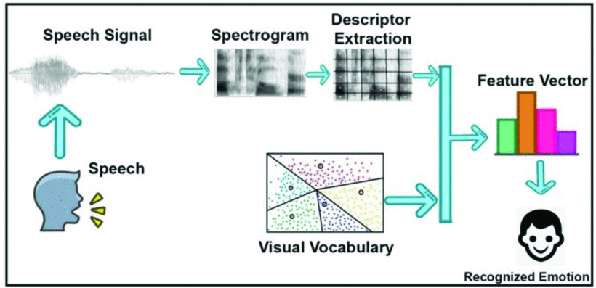

Recognised voice

## **Fig. 3.5 Methodology. Adapted from Babu, et. al. (2021)**

## **3.5.1 Model selection**

As discussed in Chapter 2, there is a lack of research on the application of deep learning on audio forensics. Unlike DL models, ML models have been greatly used for similar investigation and this has steered the reason for this study. In this study, a DL model will be trained and evaluated using different metrics. Model training entails instructing an algorithm to identify patterns and make predictions based on input data. During this phase, the model receives input data, generates predictions, and compares them to the actual labels. The model's parameters are then adjusted according to the error calculated from these predictions (Ayyappan, 2021). The goal is for the model to understand patterns and relationships within the data, allowing it to generalize and accurately predict outcomes on new or unseen data (Priya and Saradha, 2021).

Therefore, in this study, DL, and forensic linguistics methods are explored and implemented, using the python programming language. DL libraries such as Librosa, Tensorflow, and Matplotlib are used. DL algorithm namely Artificial Neural Networks (ANNs) is employed to evaluate their effectiveness in CI, and lastly, linguistic audio classifier, MFCC is employed as it is effective and instrumental in detecting linguistic patterns and characteristics. The ANN model is selected based on its effectiveness for classification tasks and its low use in the literature. The implementation and results are shown and discussed in **Chapter 4**.

#### **3.5.1.1** **Python Programming Language**

Python is a popular programming language created by Guido Van Rossum in 1989 (Coursehero, n.d). Python is a multi-purpose programming language with its design emphasis on its high ability to read code. It aids faster and easier work, and helps integrate systems more effectively (Van, Rossum. 2007).This Python programming language is used in this research for implementation purpose, as it provides efficient and straightforward open-source libraries such as Tensorflow, pandas, librosa, numpy, sklearn, seaborn, matplotlib, and so on. For this study, feature selection libraries -Tensorflow, librosa, and matplotlib- will be utilised.

#### **3.5.1.2 TensorFlow**

TensorFlow serves as a Deep Learning (DL) framework designed specifically for deep neural network (DNN) models. Its support facilitates the easy use of DL models. DL models in TensorFlow comprises of interconnected artificial neurons organised into multiple layers. The framework provides a diverse selection of pre-built layers, activation functions, loss functions, and optimisation algorithms that could be readily used for the construction of DL models(Modi and Dayma, 2017).

## **3.5.1.3 Librosa Library**

## Librosa is a Python package designed for audio and music analysis, offering essential tools for developing music information retrieval systems. Notable featuresof this tool include spectral analysis and feature extraction, enabling users to input and modify audio files. Librosa supports operations such as Short-time Fourier transform (STFT), spectral bandwidth, and spectral flatness, and it can create instantaneous-frequency spectrograms and plot the resulting graphs (Pin-Yu, et. al. 2022).

## **3.5.1.4 Matplotlib**

Matplotlib is a graphics library for data visualisation package in Python and is one of the most popularly used visualisation library.

**PYTHON PROGRAMMING LIBRARIES**

## **Fig. 3.6 Python programming libraries.**

**LINGUISTIC TOOLS**

## **Fig. 3.7 Linguistic Analysis Tools**

## **3.5.1.5 Artificial Neural Networks (ANNs)**

An Artificial neural network (ANN) is a class of deep neural networks, that teaches computers to process data in a way that is inspired by the human brain using interconnected nodes or neurons in a layered (AWS, n.d). In this study, ANN models are implemented to analyse human speech despite varying speech patterns, pitch, tone, language, and accent. Like any typical neural network, ANNs are based on **neurons**that are organized in layers and can, hence, learn hierarchical representations Neural networks (NNs) are designed to learn the spatial features, e.g. edges, corners, textures, or more [abstract shapes](https://www.sciencedirect.com/topics/computer-science/abstract-shape), that best describe the target class or quantity (Kattenborn et al. 2021).

## **3.5.1.6 MFCC**

Mel-Frequency Cepstral Coefficients (MFCCs) play an instrumental part in the deep learning application of forensic linguistics in audio investigation. Derived from the spectral characteristics of audio signals, MFCCs are instrumental in representing linguistic patterns and speaker characteristics crucial for forensic analysis. In this context, the extraction of MFCCs involves framing the audio recordings, applying windowing functions to mitigate spectral leakage, computing the power spectrum, and subsequently filtering through Mel filters. The resulting log-filterbank energies are then subjected to a Discrete Cosine Transform to extract relevant features essential for deep learning models. By leveraging MFCCs, deep learning algorithms can effectively analyse linguistic cues indicative of particular speech pattern, aiding in speaker identification, deception detection, and the interpretation of forensic evidence within audio recordings. Thus, MFCCs serve as a foundational element in the integration of deep learning techniques with forensic linguistics for enhanced audio crime investigation.

## **3.5.2. Sample and Sampling Techniques**

The process of selecting an appropriate sample and sampling technique is mostly based on the unique features of the dataset and the desired balance between accuracy and computational resources(Sanabila and Jatmiko, 2018). A sample refers to a group from which specific information is gathered. Conversely, sampling is the process of selecting a subset of individuals from a larger, defined population (Gall and Borg, 2006). According to Dominick (2006), the entire populace of a particular study cannot be examined due to time. Thus, the sample size for this research is 500 words comprising of 250 ground truth data and 250 noise data (5 speakers). The selected data/sample size was selected based on the first words that a human child learns between the ages of 1-3 e.g. by age one, research has it that children recognise 50 words, and by age three they recognise about 1000 words (Franzo et.al. 2017). A stratified probability sampling technique was used in this study since the population is heterogenous.

## **3.6 Instrument for Data Collection**

**RECORDING & SONIC VISUALIZATION TOOLS**

## **Figure 3.8 Recording and visualisation tools**

## **3.7 Evaluation and Metrics**

To properly evaluate the performance of our model, appropriate metrics such as accuracy, precision, MSE, and ROC-AUC could be used. Due to the nature of data (audio), this research will use the following metrics to evaluate and compare the results of models (Haibo He and Garcia, 2009).

#### **3.7.1.1** **Accuracy**

Accuracy is a metrics employed to calculate how often the model correctly predicts the outcome. It represents the proportion of correct estimations made by the model, relative to the total predictions. This metric is a prevalent metric used to evaluate the overall accuracy of predictions and is computed using equations **3.1 and 3.2** (Nadim et al., 2019).

**Equation 3.1-** Accuracy = Correct Predictions / Total Predictions

**Equation 3.2-** Accuracy = TP + FP/ (TP + FP + TN + FN)

## **3.7.1.2** **Precision**

Precision shows the quality of an accurate prediction generated by the model, indicating the proportion of True Positives (TP) among the instances identified as positive. In other words, it represents the ratio of TP to the sum of TP and FP. It is calculated using equation **3.3** (Nair and Kashyap, 2019).

**Equation 3.3-** Precision = TP / (TP + FP)

## **3.7.1.3** **Recall**

Recall, alternatively called sensitivity, measures the proportion of true positive (TP) instances correctly identified out of all actual TP instances. Essentially, it signifies the TP rate and provides an overview of how effectively the positive class was predicted. Recall is calculated using equation **3.4** (Nair and Kashyap, 2019).

**Equation 3.4**- Recall =TP/(TP + FN)

## **3.7.1.4** **F1-score**

F1 Score, also known as F score or F-measure, shows the harmonic mean of the recall and precision. It comprises of values which extends from 0 to 1, i.e. 0 is worst, and 1 is best and is calculated using the equation **3.5** (Wardhani et al., 2019).

**Equation 3.5-** F1 Score=2*(Precision* Recall)/ (Precision+ Recall)

## **3.7.1.5 ROC-AUC**

Area Under Curve (AUC), as its name suggests, represents the segment of the total area beneath the ROC (Receiver Operating Characteristic) graph. AUC provides a singular value for classification performance evaluation, while ROC is computed to assess the overall quality. It is calculated using equation **3.6** (Nair and Kashyap, 2019).

**Equation 3.6-** ROC AUC = (TPR +FPR)/2

### **3.7.2 Comparison and Analysis**

The result of models would be compared in terms of the different metrics used after which analysis of the selected models will be carried out to understand the underlying reasons for the similarities and differences. In addition, comparing the findings with other study`s results, could make a clear view of the performance of this study compared with previous ones.

Although, each metric provides different insights into the model's performance, such as overall accuracy, precision, and recall, however, a single metric cannot be used to assess the model's performance. Therefore, a combination of metrics to gain a comprehensive understanding of strengths and weaknesses would be advised and should be used. For example, accuracy may be high, but if the model has low recall, it could be missing important positive instances(Sisodia et al., 2017).

## **3.8 Ethical Considerations**

This research will consider the following ethics.

1. Informed Consent: The dataset of this study uses voices from people (sourced primarily); hence, informed consent will be required.
2. Privacy and Data Protection: This research will ensure that the data collected is secure and confidential.
3. Bias and Fairness: Deep learning models are susceptible to bias; therefore, this research will ensure that the algorithms are fair and unbiased, and do not discriminate against any gender or individual.
4. Transparency: Researcher would ensure transparency in the research methodology and ensure that the models and algorithms are explainable and understandable.
5. Misuse of Results: The results could potentially be misused by individuals or organisations for fraudulent purposes. To prevent this, the researchers would be transparent about methods and findings, and communicate the limitations of their models.
6. Ethical Review: The research would undergo ethical review by the institutional research ethics board to ensure that the research is conducted in an ethical and responsible manner.

## **3.9 Summary**

In summary, the methodology adopted for this study encompasses a mixed-method research design with an experimental approach. This selection is based on the nature of the research questions, the study's scope, and the type of available data. By integrating both qualitative and quantitative research methods, the study seeks to leverage sound, image, and numerical data to evaluate model performance for Crime Investigation (CI) within the context of deep learning and forensic linguistics.

The research design entails systematic data collection, analysis, and interpretation to yield meaningful insights and dependable conclusions. The proposed workflow comprises several crucial steps, including data preparation, feature selection, data partitioning, sampling techniques, model selection (utilizing deep learning), training and testing the chosen models, and analysing them to derive interpretations and results.

The research data consists of a publicly sourced dataset obtained from private individuals, and the implementation and analysis are conducted using the Python programming language along with various libraries. For evaluation purposes, a range of metrics, particularly precision, accuracy, and F1-score, are employed. Ultimately, the results will be compared and evaluated.

## **CHAPTER 4: ANALYSIS, IMPLEMENTATION AND RESULTS**

This chapter presents the analysis of our data and findings of the research conducted to address the challenges of Forensic Linguistics (FL) in detecting audio crimes using deep learning (DL). After data collection and sampling, the data algorithms will be applied to the data. After training and validating the model, the results obtained from the technique is analysed. A comparative analysis of the operation of various algorithms is conducted. The metrics used for evaluation are examined to identify the techniques that ranked the highest in detecting a voice accurately. This study is implemented by Python language in Anaconda Jupiter notebook using different libraries namely Librosa, Tensorflow, and matplotlib.

## **4.1 Exploratory Data Analysis (EDA)/Data Preprocessing**

To have a better understanding of this section, Exploratory Data Analysis will be carried out. This section outlines the steps taken to prepare and preprocess the audio data before feeding it into the deep learning models. Exploratory Data Analysis (EDA) is an approach to analysing datasets to summarize their main characteristics, often with the use of visual methods. Exploratory data analysis (EDA) is made use of on virtually every data set that is collected and also is one of the most essential actions in any type of evaluation. The primary objectives of EDA are to understand the data collection, extract crucial variables and also to find out hidden details (Kanit et.al. 2019). It consists of generating summaries and also visualizing information, often incorporating this with statistical designs (Saskia et.al. 2020). EDA is all about seeing just what the data could inform us prior to the harder official modeling. Our EDA will encompass stages such as data cleaning and conversion, data exploration and visualisation, this is to help the study understand the data, identify patterns, spot anomalies, and generate hypotheses that can inform further analysis or investigation.

## **4.2 Data Cleaning**

Before the data cleaning stage commences, the dataset will first be imported into python alongside the relevant python packages. The Data Cleaning stage requires the checking of the dataset for missing words, null or wrong class, and duplicate records. However, as the dataset is initially cleaned and primary with no missing nor duplicate words, (see **Figure 4.1**) there is no need to manipulate the data.

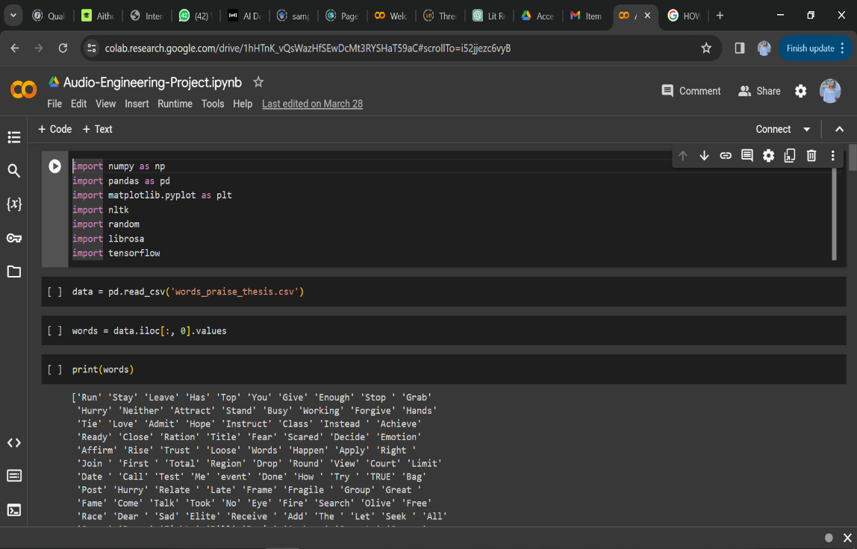

## **Fig 4.1: Importing python libraries and dataset**

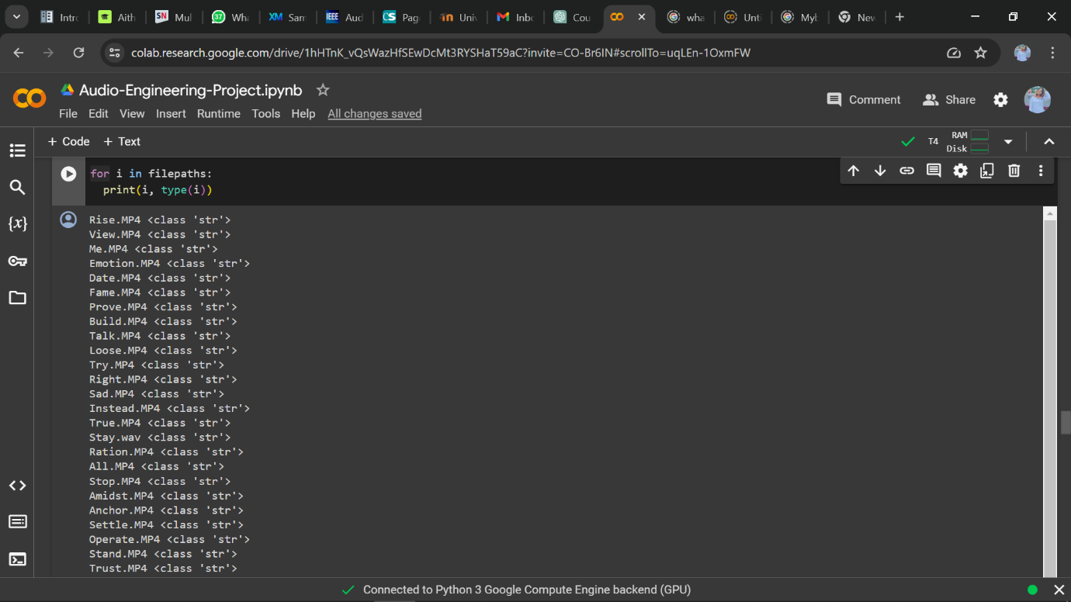

## **Fig 4.2: Checking the data class**

Using for i in filepaths: print(i, type(i)), we can check the class of the dataset and from fig 4.2, we see that the entire dataset class shows string, indicating that theres no need for any cleaning nor wrong data.

## **4.3 Data Conversion**

Data Conversion will involve converting the audio files from its original form to a form that can be analysed by python program. This will mean converting the audio to wav files and then to spectrograms.

## **4.4 Visualisation of Data**

Visualization plays a central role in EDA, as it helps analysts explore and interpret complex datasets more effectively. In this research, various types of visualisations including waveform, spectral frequency, spectral pitch, will be used to visualize different aspects of the data.

## **4.4.1 Waveform**

According to the Collins dictionary (nd.), the term waveform describes a depiction of the pattern of sound pressure variation (or amplitude) in the time domain. Simply put, the waveform would show the variations in air pressure over time as the person speaks. It's typically displayed as a graph with time on the x-axis and amplitude on the y-axis. Peaks and valleys in the waveform indicate variations in the sound's intensity or volume. As seen in **fig 4.3 to 4.5** shows the process of converting the audio to waveplot.

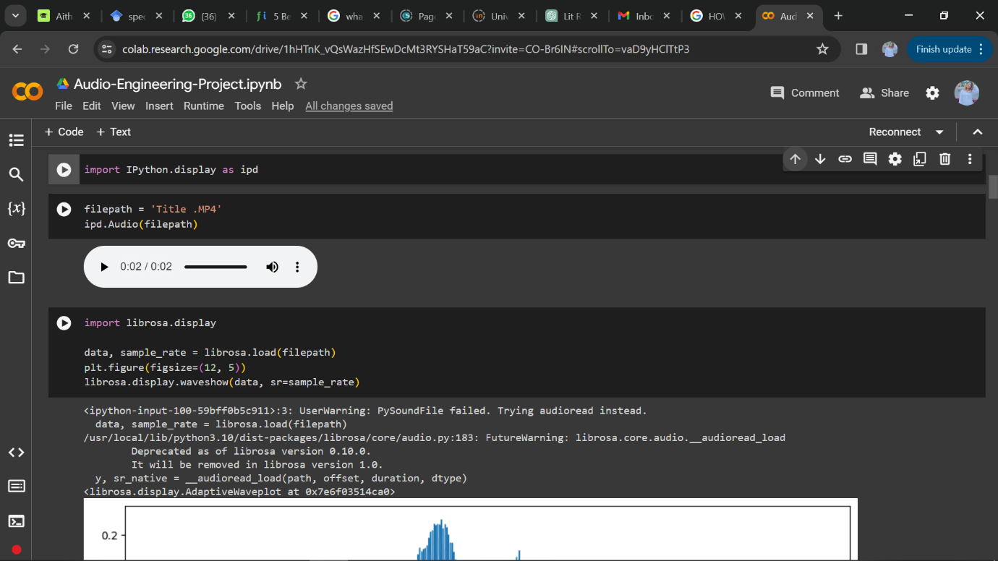

## **Fig 4.3: Importing the wav file**

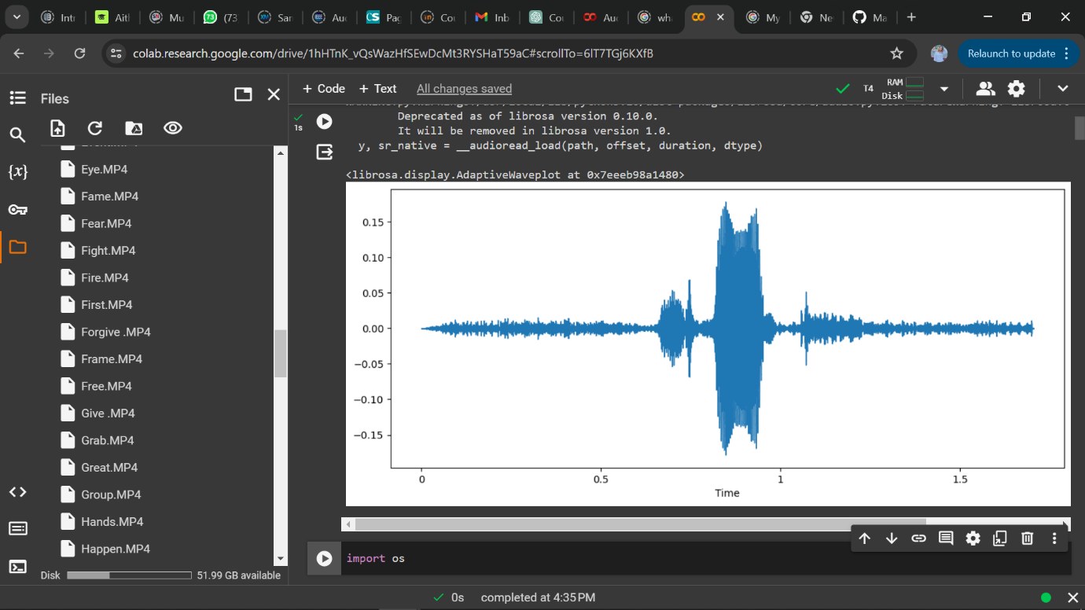

## **Fig. 4.4 Waveplot sample of the ground truth voice using the sound ‘Group’.**

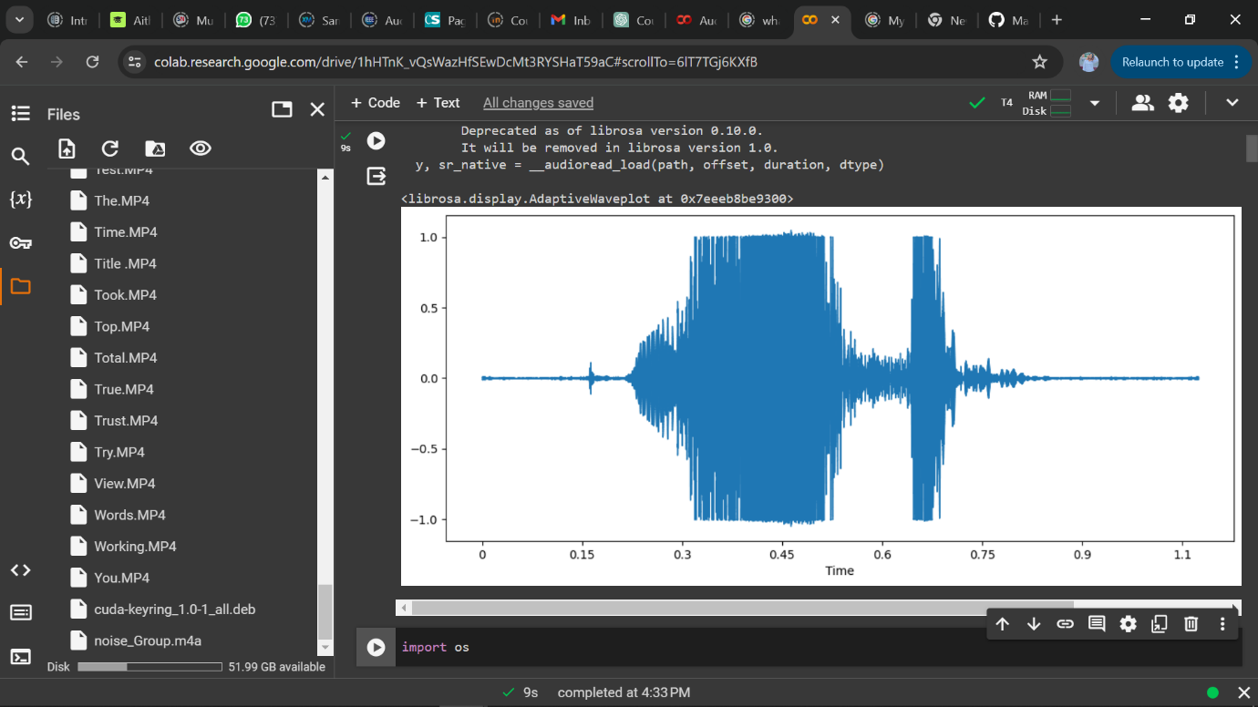

**Fig. 4.5 Wave plot sample of a noise data voice using the sound ‘Group’**

In figure 4.4 and 4.5, we can notice a difference in the wave strokes. Figure 4,3 shows a wave plot having lighter strokes, i.e. the wave plot shows a lighter and higher pitch hence the lighter wave, unlike figure 4.4 showing thicker strokes which is indicative of a deeper and lower pitch. From this analysis, we can simply deduce using the information from Watson’s book ‘Message not received: When women’s voices go unheard’, that figure 4.3 shows the wave plot of a female voice and figure 4.4 is that of a male voice (Watson, 2019).

## **4.4.2 Spectrogram**

A spectrogram represents the frequency content of a sound over time. involves generating a visual representation of the spectrum of frequencies in the audio file as they vary with time (Arias-Vergara, et.al. 2021). Spectrograms show the distribution of frequencies that make up the different phonemes in a word therefore can be said to be better for analyzing frequency content, identifying sounds, and detecting patterns or anomalies. To further understand a spectrogram, on the y-axis, spectrograms display the frequency, while time is displayed on the x-axis, and intensity or amplitude is represented by colors or grayscale as will be seen in fig. 4.3

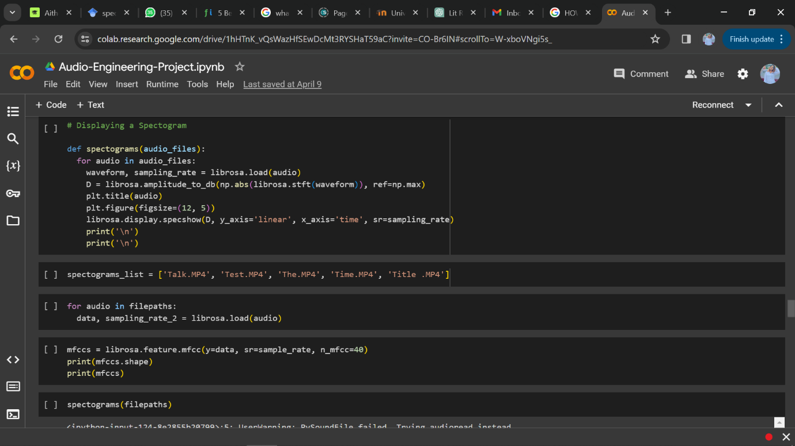

## **Fig 4.5 Converting the wav file to spectrogram**

After importing the wav file using import IPython.display as ip, the next stage loads the WAV file using librosa.load. It then calculates the short-time Fourier transform (STFT) using librosa.stft and converts it to a decibel scale with librosa.amplitude_to_db. The result is displayed using librosa.display.specshow, which handles the complex plotting aspects of the spectrogram. **Figures 4.6 to 4.8** shows the results of spectrogram plotting.

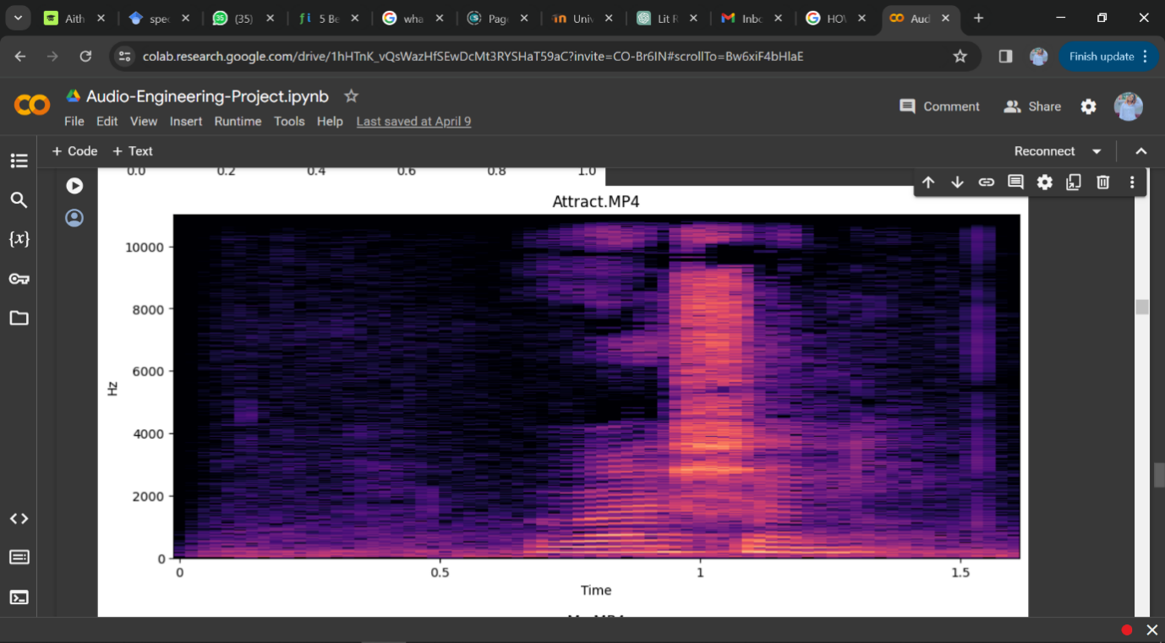

## **Fig. 4.6 Spectrogram showing frequency distribution of sounds of the word ‘Attract’**

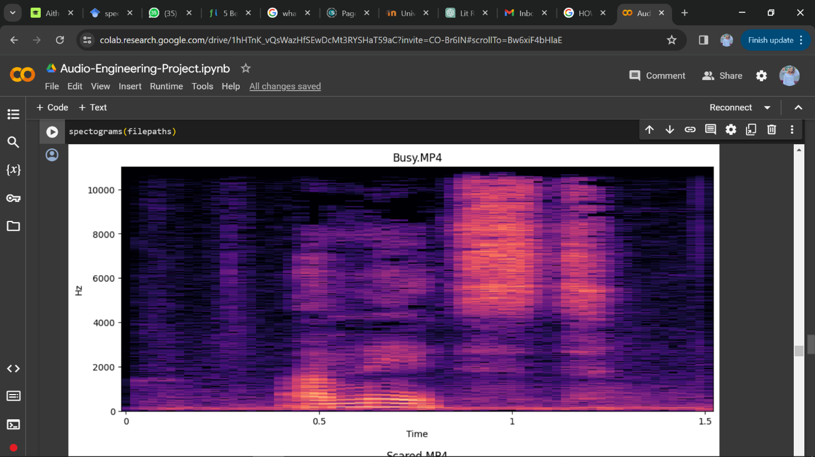

## **Fig. 4.7 Spectrogram showing frequency distribution of sounds of the word ‘Busy’.**

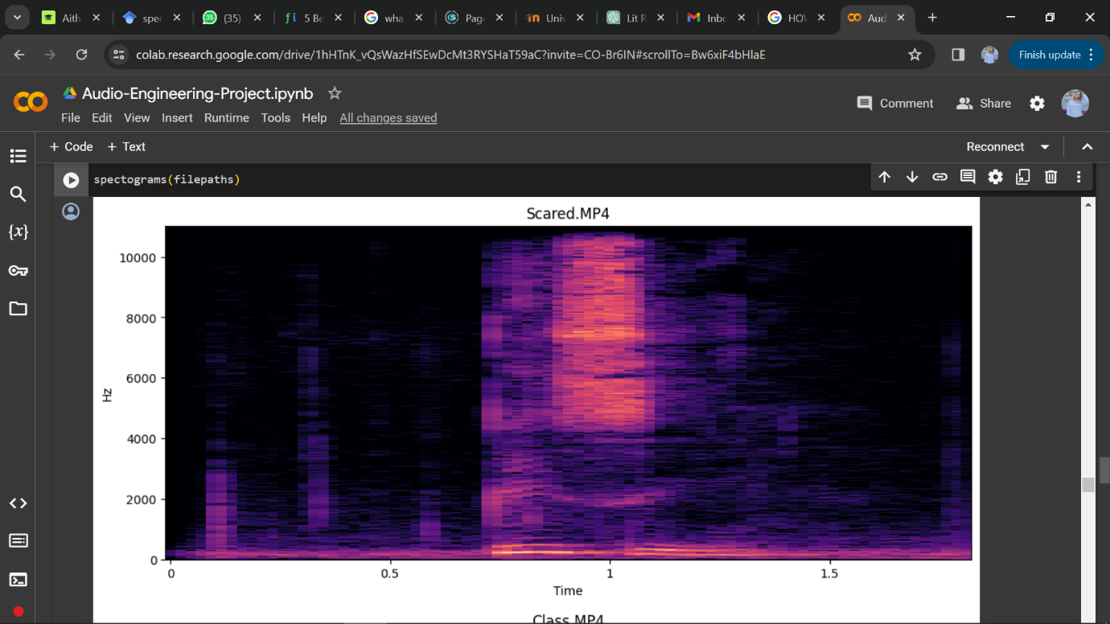

## **Fig. 4.8 Spectrogram showing frequency distribution of sounds of the word ‘Scared’**

From the figures above, we can deduce the following; The x-axis represents time in seconds, and the y-axis represents frequency in hertz. These particular spectrograms span over approximately 1.5 seconds and displays frequencies up to 10 kHz, which covers the range of most fundamental speech frequencies and many of its harmonics. Also, it can be noticed that these spectrograms show a dense concentration of energy in the lower frequencies (below 2 kHz), which is common in human speech as this area typically contains the fundamental frequency of the voice and its lower harmonics. The intensity of colors represents the energy or loudness at each frequency at a given time, with brighter colors indicating higher energy or stronger presence of certain frequencies at a given time such as pitch, harmonics, and timbre variations.

The horizontal bands, which is particularly evident in the lower frequency region, could be indicative of formants. Formants are resonant frequencies of the vocal tract that are crucial for vowel sounds identification. So, with these formants, once can deduce the presence of a vowel sound in the speech. In speech analysis, formants are important features for speaker identification and characterization.

There are areas where the intensity varies (can be seen by changes in color brightness), and there are also vertical gaps with less or no energy, which could represent pauses or stops in the speech or audio signal. Also, the relatively consistent energy at certain frequencies across the spectrogram are indicative of background noise in the recording environment.

## **4.5 Feature Engineering**

For a proper feature extraction, a methodology was presented to enhance the ground-truth audio data and the noise audio data using spectrograms and ANNs. In this work, the short-time Fourier transform (STFT) is computed to form a 2D-layer (2 input and 1 output layer), which is then processed by the convolution layers; thus, extracting the feature maps. Mel-Frequency Cepstral Coefficients (MFCCs), derived from the spectral characteristics of audio signals, are instrumental in representing linguistic patterns and speaker characteristics crucial for forensic analysis. Therefore, in this experiment, feature extraction will be carried out using MFCCs which involves framing the audio recordings, applying windowing functions to mitigate spectral leakage, computing the power spectrum, and subsequently filtering through Mel filters. Using !pip install resampy, a well suited audio module in python for time-frequency (spectrogram) resampling (Smith, 2015), the audio sounds will be resampled to enhance its quality. The processes of feature extraction are shown in **figs 4.10.**

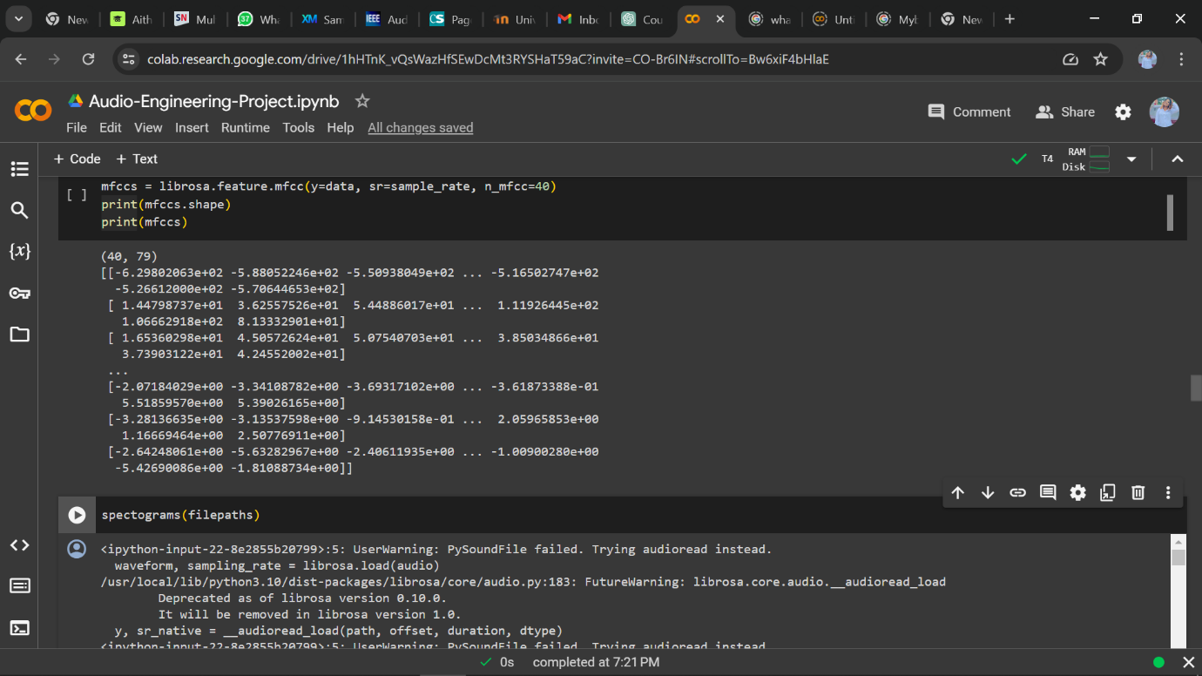

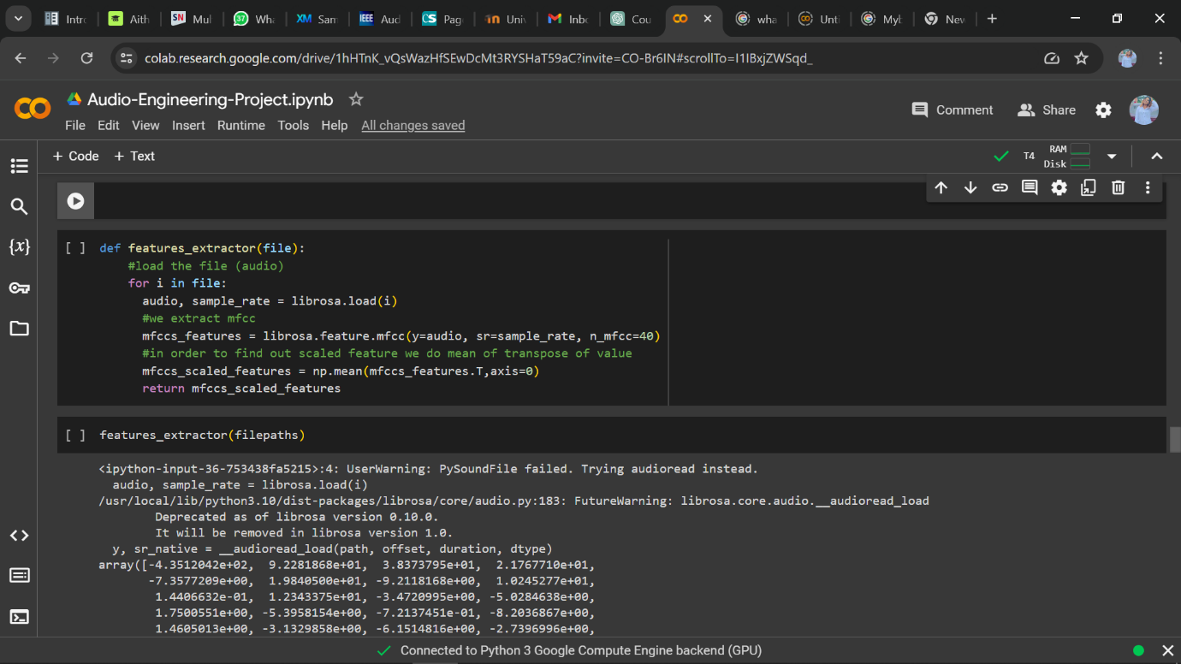

## **Figs 4.9: Loading and extracting features from audio using MFCCs**

Mel Frequency Cepstral Coefficients (MFCCs) are utilized because they effectively represent the timbral aspects of the audio signal, and the mean of transpose of value is applied to normalize MFCC features, enhancing model performance by ensuring each feature contributes equally. **Figure 4.10** and **4.11** below shows the features extracted from the word ‘class’ from both the ground truth data and the noise data.

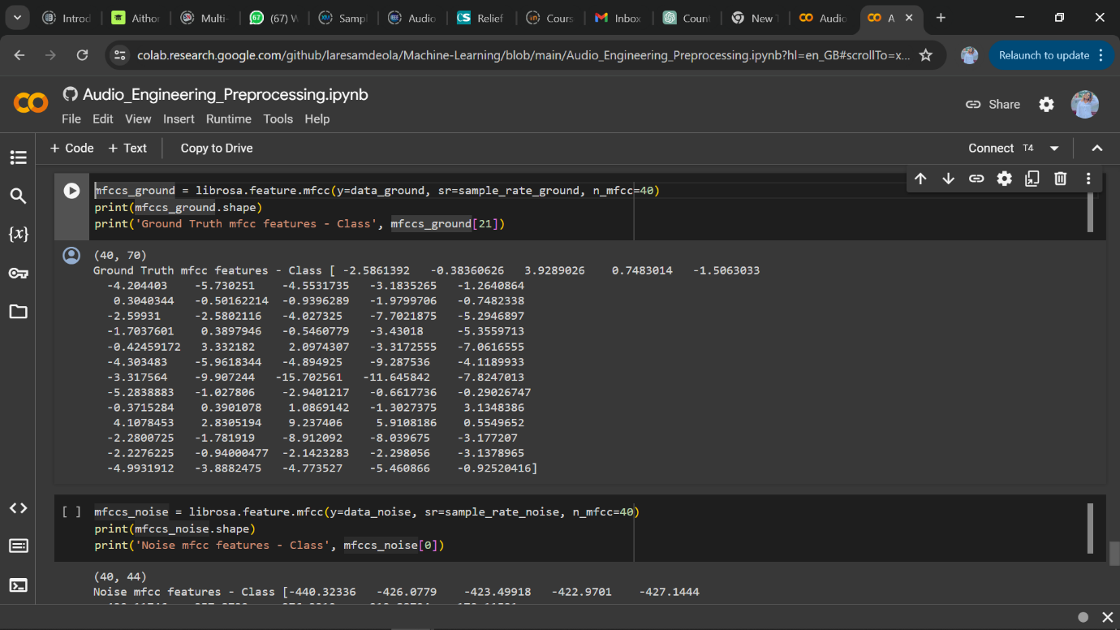

## **Fig. 4.10 MFCC Features in the word ‘class’- Ground truth data**

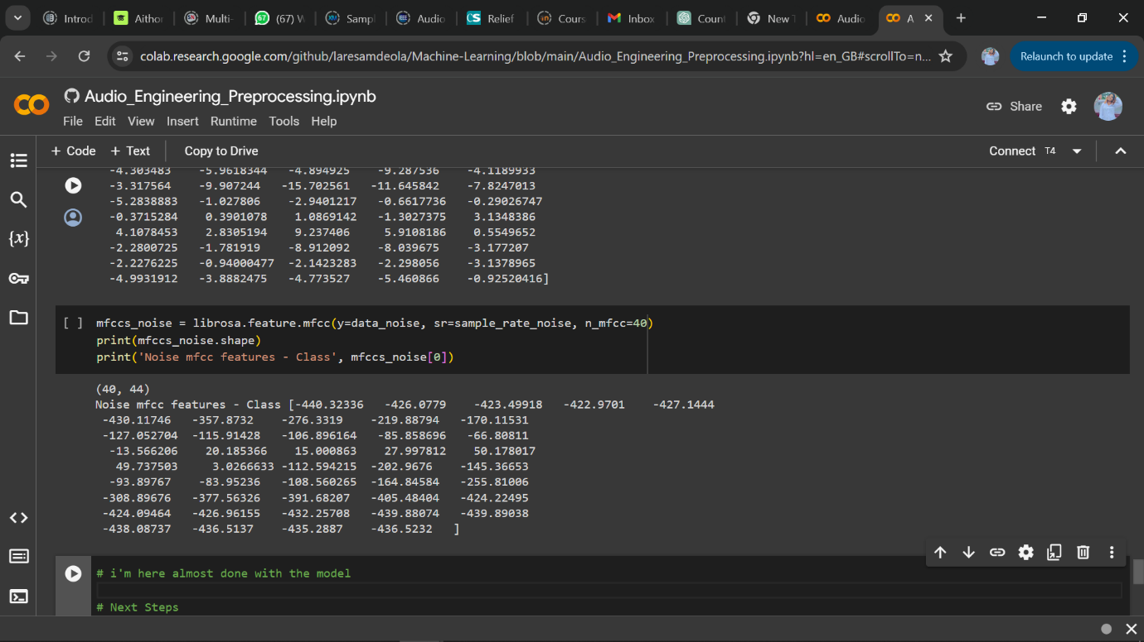

## **Fig. 4.11 MFCC Features in the word class- Noise data**

## 

## **Fig 4.12 Installing resampy to improve dataset quality**

## **Fig 4.13 Converting Extracted Features to Dataframe**

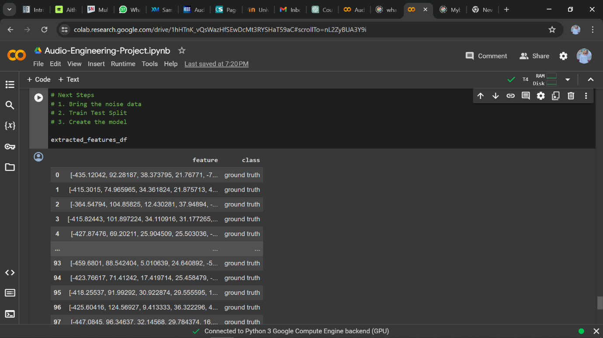

## **Fig 4.14 Extracted Features Data frame**

## **4.6** **Building the Audio Model**

## **4.6.1 Data Splitting**

Data is split into a training set and a testing set, allowing the model to learn from a diverse subset of data and validate its performance on unseen data.This study uses 80% of the data to train the models and 20% to test the performance of them. to do so, after randomly shuffling the data, it is split into X_train, X_test, y_train and y_test sets, as it is shown in **Figure 4.15**.

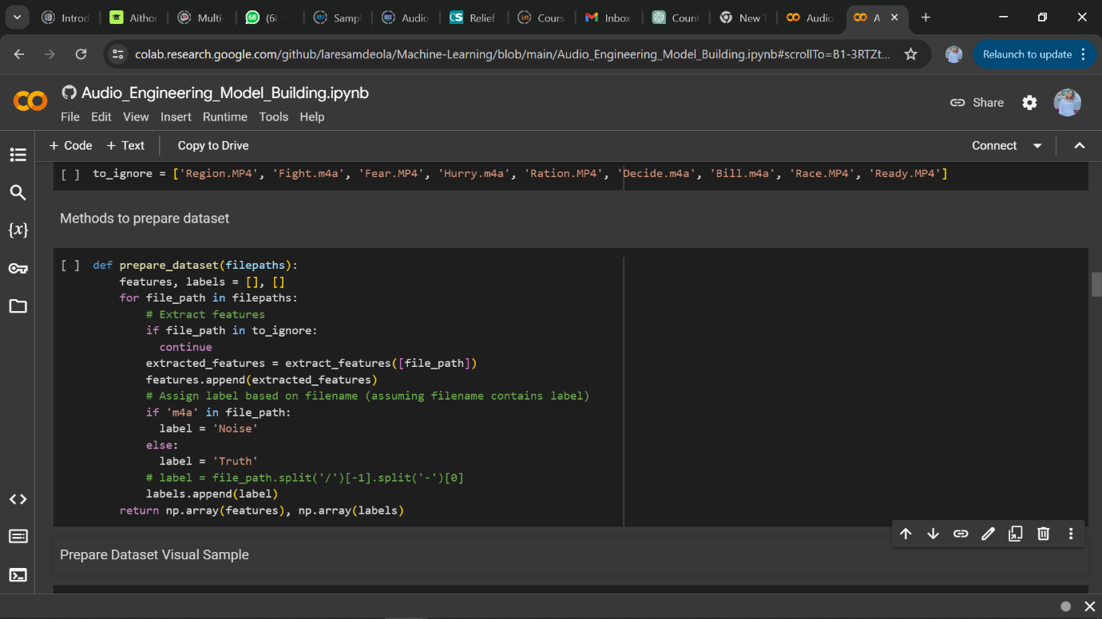

## **Fig. 4.15** **Method of preparing the dataset for splitting**

In figures **4.16** and **4.17**, we see the result of annotating the dataset with labels using the process shown in **fig 4.15** giving us the x (features) and y (labels) variables.

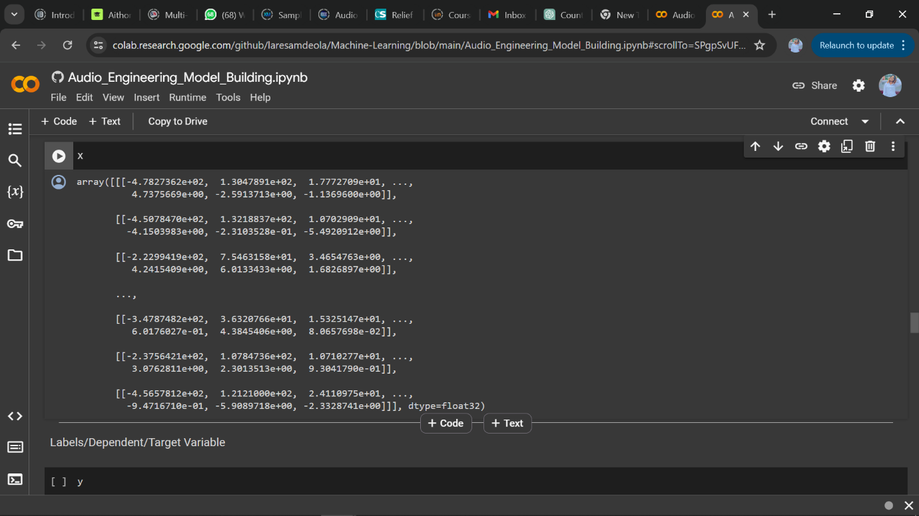

## **Fig. 4.16 X/feature variables**

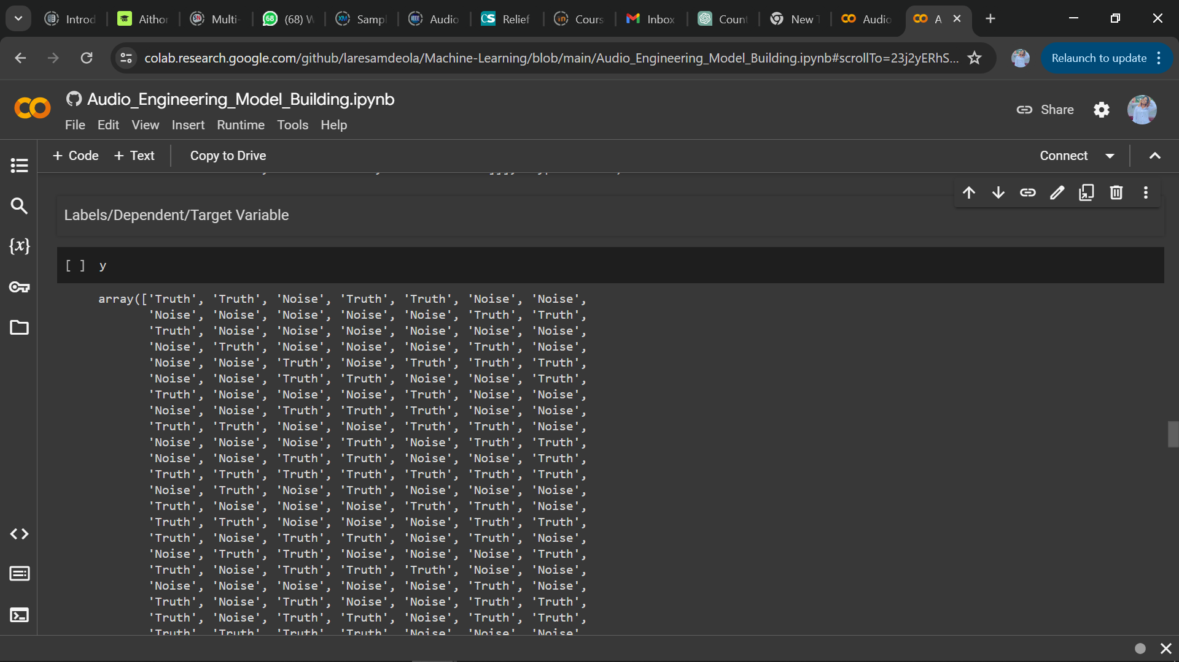

## **Fig. 4.17 Y/Label variables**

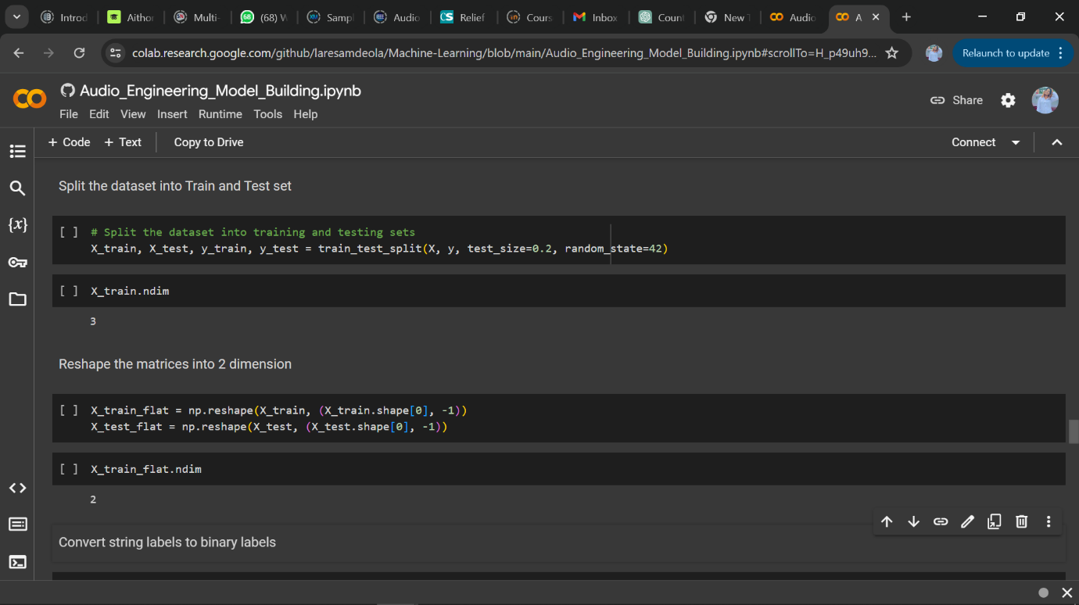

## **Fig. 4.18 Splitting the dataset**

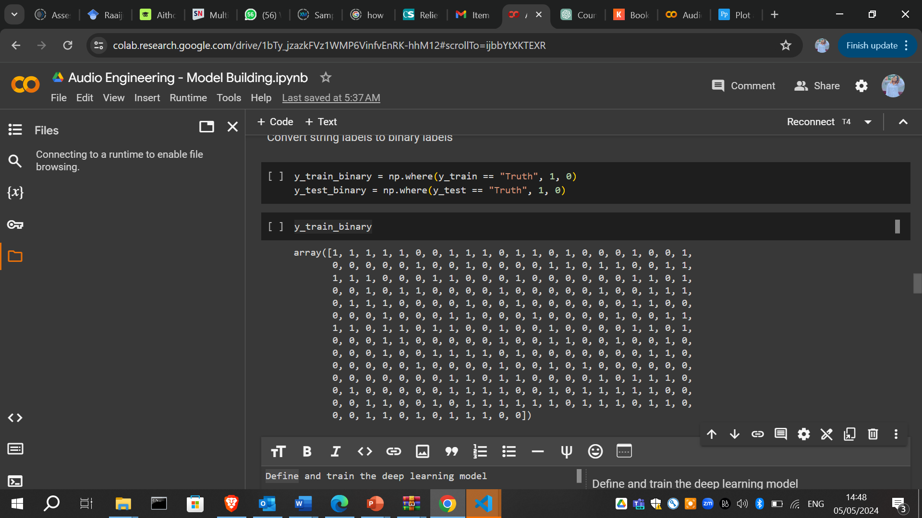

## **Fig. 4.19 Converting string labels to binary labels.**

## **4.6.2 Model Training and Evaluation**

This process describes the deep learning model architecture, training process, and parameter tuning. All the metrics shown in figure 4.18 are trained by the ground truth audio data in 10 run times.

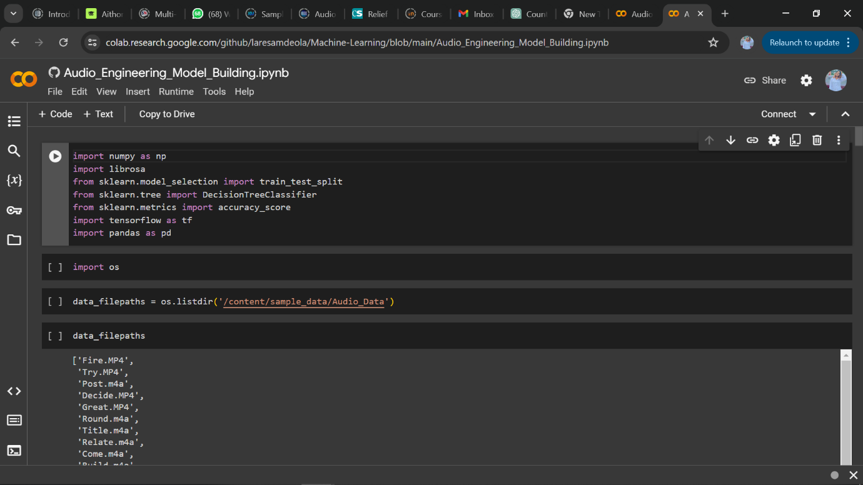

## **Fig. 4.20 Importing relevant model building**

## **libraries**

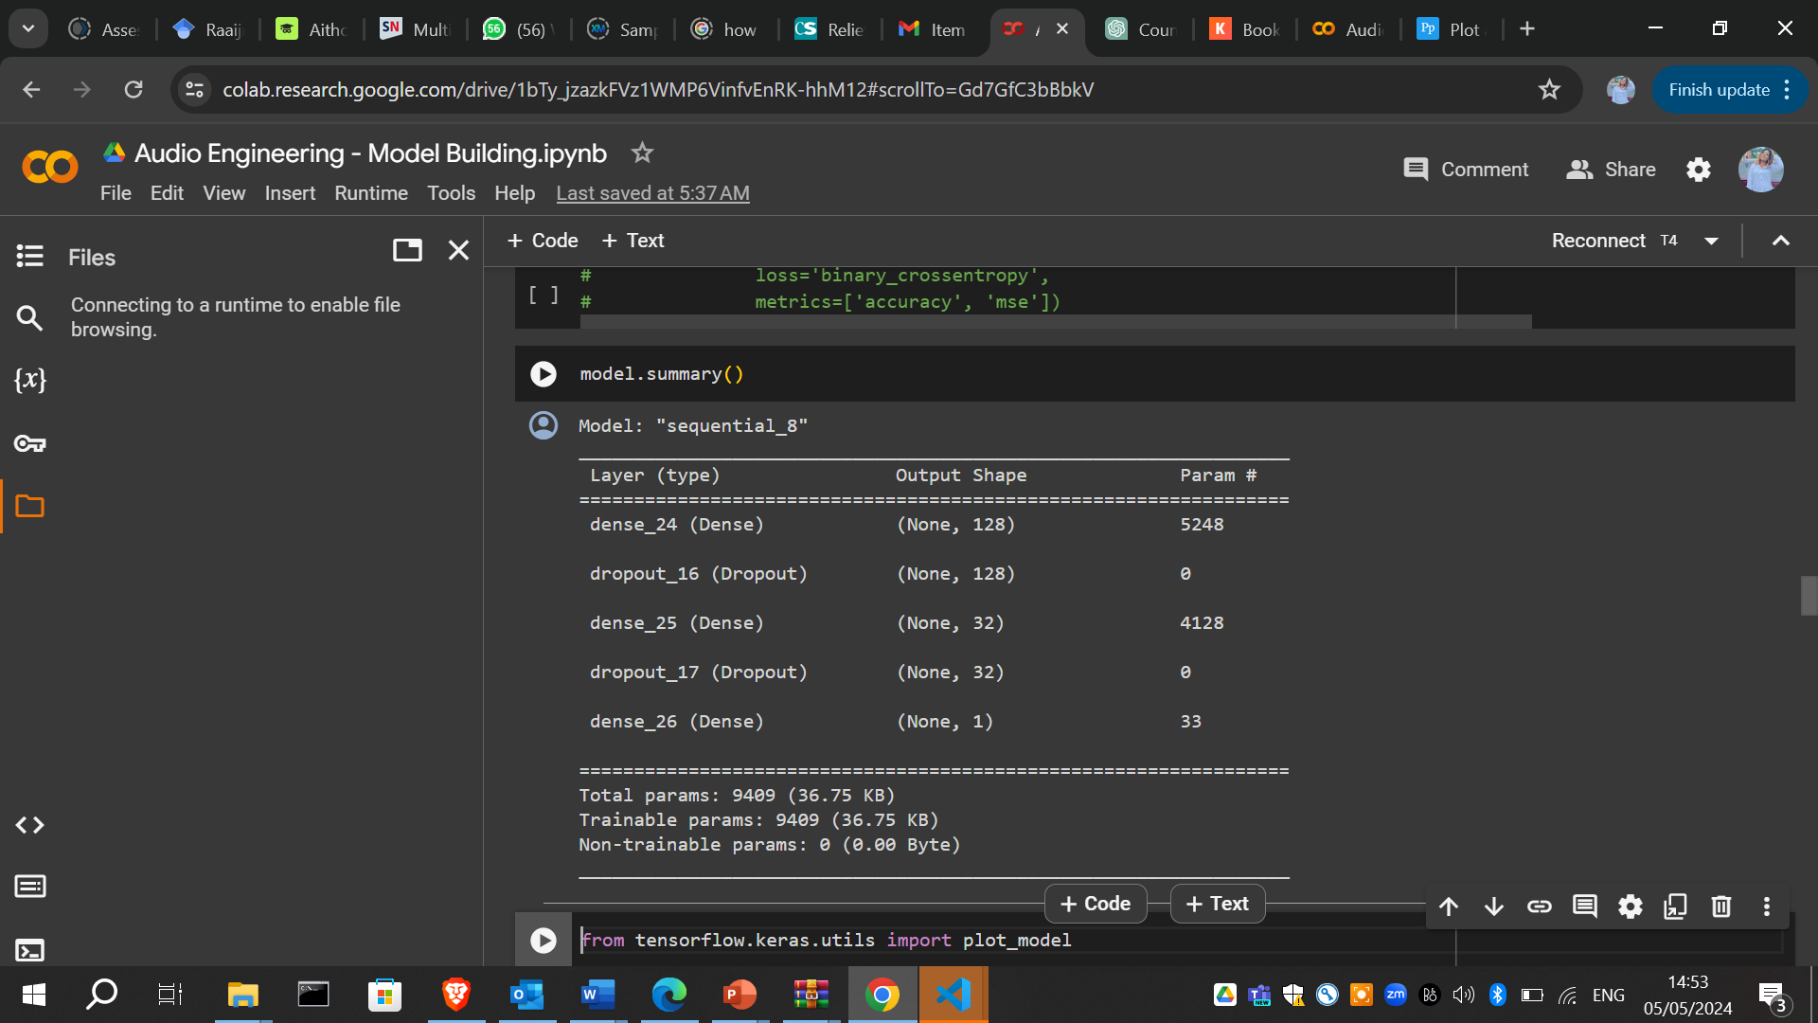

## **Figs. 4.21 Defining and training the deep learning model**

The model uses tensorflow as it aids building and training of deep learning models as well as the efficient execution of models. This was also used to ensure the model generalizes well to new data. The Adam optimizer and binary cross-entropy loss function are chosen arbitrarily because of their efficient training and performance on binary classification tasks.

After defining and training the DL model, we plot the model’s architecture and the result can be seen in figure **4.22.**

from tensorflow.keras.utils import plot_model

#Plot the model's architecture

plot_model(model, to_file='model_plot.png', show_shapes=True, show_layer_names=True)

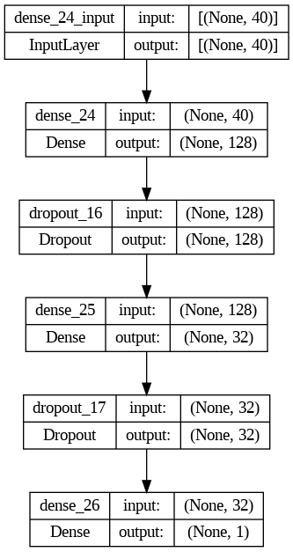­­­

## **Figs. 4.22 Plotting the DL model’s architecture.**

Figure **4.22** typically shows the process flow of the ANN model. In this process, data enters through the Input Layer where the initial feature set is processed, followed by the first dense layer. The first Dense layer expands the feature set to 128 dimensions, likely integrating more complex interactions between features. The first Dense layer is followed by a Dropout layer which reduces overfitting by randomly disabling some of these features during training.

The process repeats with another Dense layer reducing the dimensions to 32, followed by another Dropout. Finally, the output Dense layer compress these features down to a single value. The dropout function is used to generalise the model better by preventing overfitting to the training data.

After plotting the DL model’s architecture, the next process displays the 3D surface plot of neurons using the Artificial Neural Network architecture. This is so we can show the output of the function across the ‘Truth’ and ‘Noise’ variables.

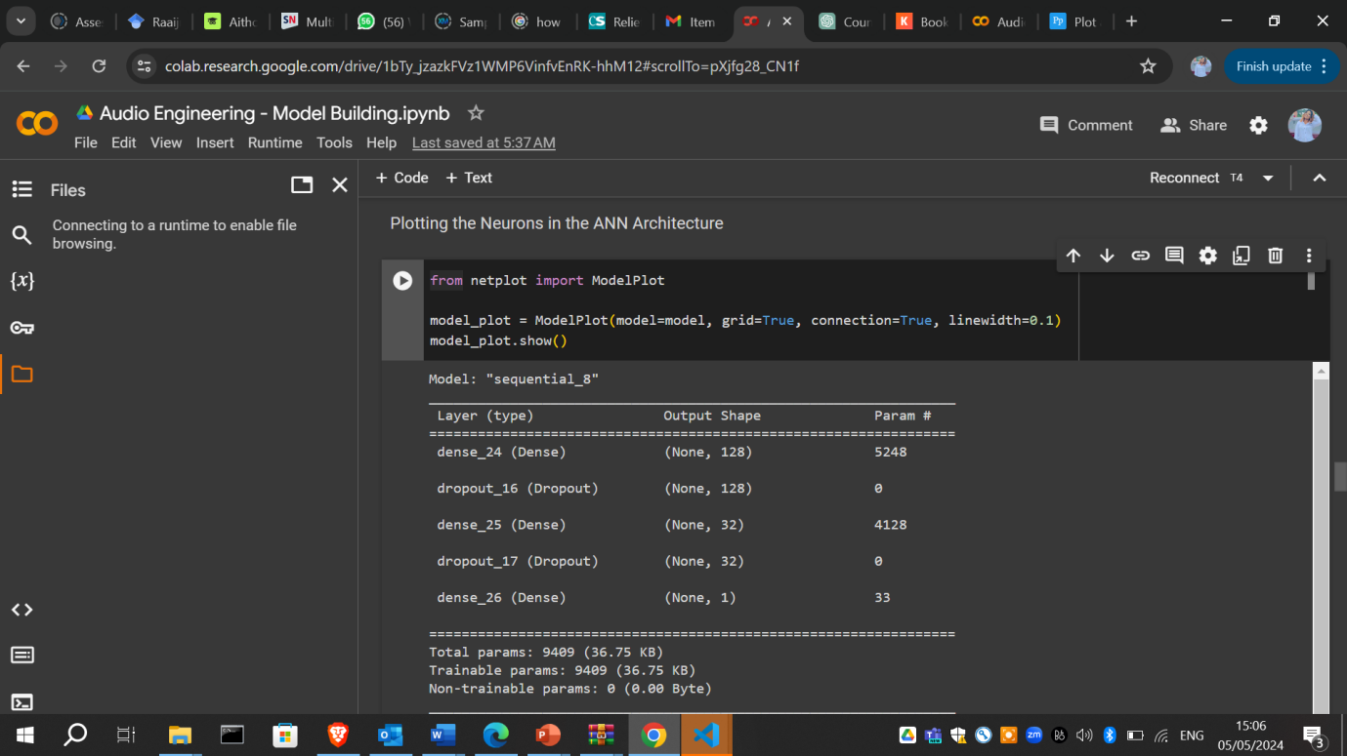

## 

## **Figs. 4.23: A 3D Plot of neurons using the Artificial Neural Network Architecture**

The plot in figure **4.23** depicts a plot with 3 axes. The x-axis, the y-axis, and the z-axis. The x-axis is made up of values ranging from 0 to about 120. This axis represents one dimension of input parameters. The y-axis on another hand, ranges from 0 to about 25, which also represents another dimension of the input affecting the outcome. And the z-axis comprises of values ranging from -0.04 to 0.04. The small size of this axis is indicative of an activation/dropout level in the neural network. The larger peak in the plot that spans much of the x-axis indicates areas of higher activity or higher values, and the smaller, sharper peak near the centre of the plot indicates areas of lower activity or values.

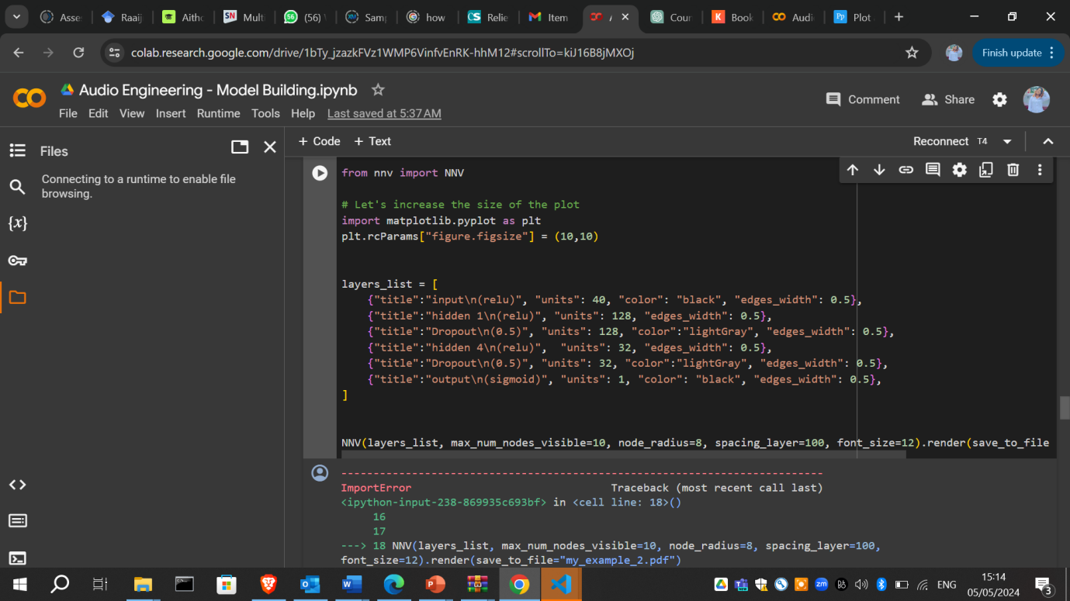

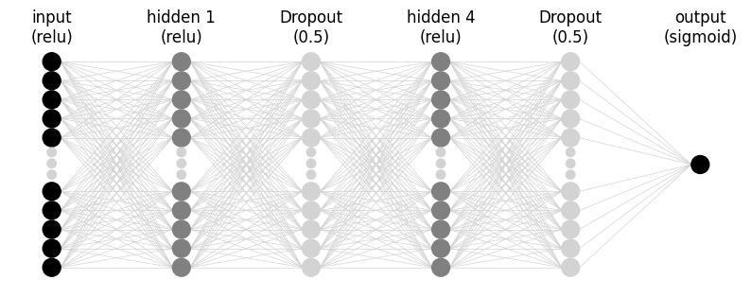

## **Figs. 4.24 Plotting the neurons in the ANN Architecture (Hidden layers and dropout)**

Using the Neural Network Verification Tool (NNV), a software framework that performs set-based verification for Deep Neural Networks (DNNs) and neural network control systems (NNCS) (Tran, et al. 2020), figure **4.24** plots the hidden and dropout layers in the ANN architecture. The analysis of this figure is seen below.

The first layer which is the input layer is not a computational layer, but it simply takes in the input which are processed using the ReLU (Rectified Linear Unit) activation function and passes it on to the first hidden layer. ReLU is commonly used because it introduces non-linearity without affecting the scale of the input, helping to prevent vanishing gradient issues. The first hidden layer proceeds to convert the input data by assigning a linear transformation (using weights and biases) followed by the ReLU non-linear activation.

After the first hidden layer, a dropout layer is added with a dropout rate of 0.5. This rate simply means that during training, 50% of the nodes (neurons) in this layer are randomly ignored. This process helps to mitigate overfitting by making the network less sensitive to the specific weights of neurons, thereby enhancing generalisation. After the first hidden layer stage, the process goes through the final transformation process as specified in the hidden 4 layer, and another dropout rate of 0.5 is applied. Finally, the output layer of the network produces the final prediction. It uses the sigmoid activation function, which is particularly useful for binary classification tasks as it reduces the output between 0 and 1.

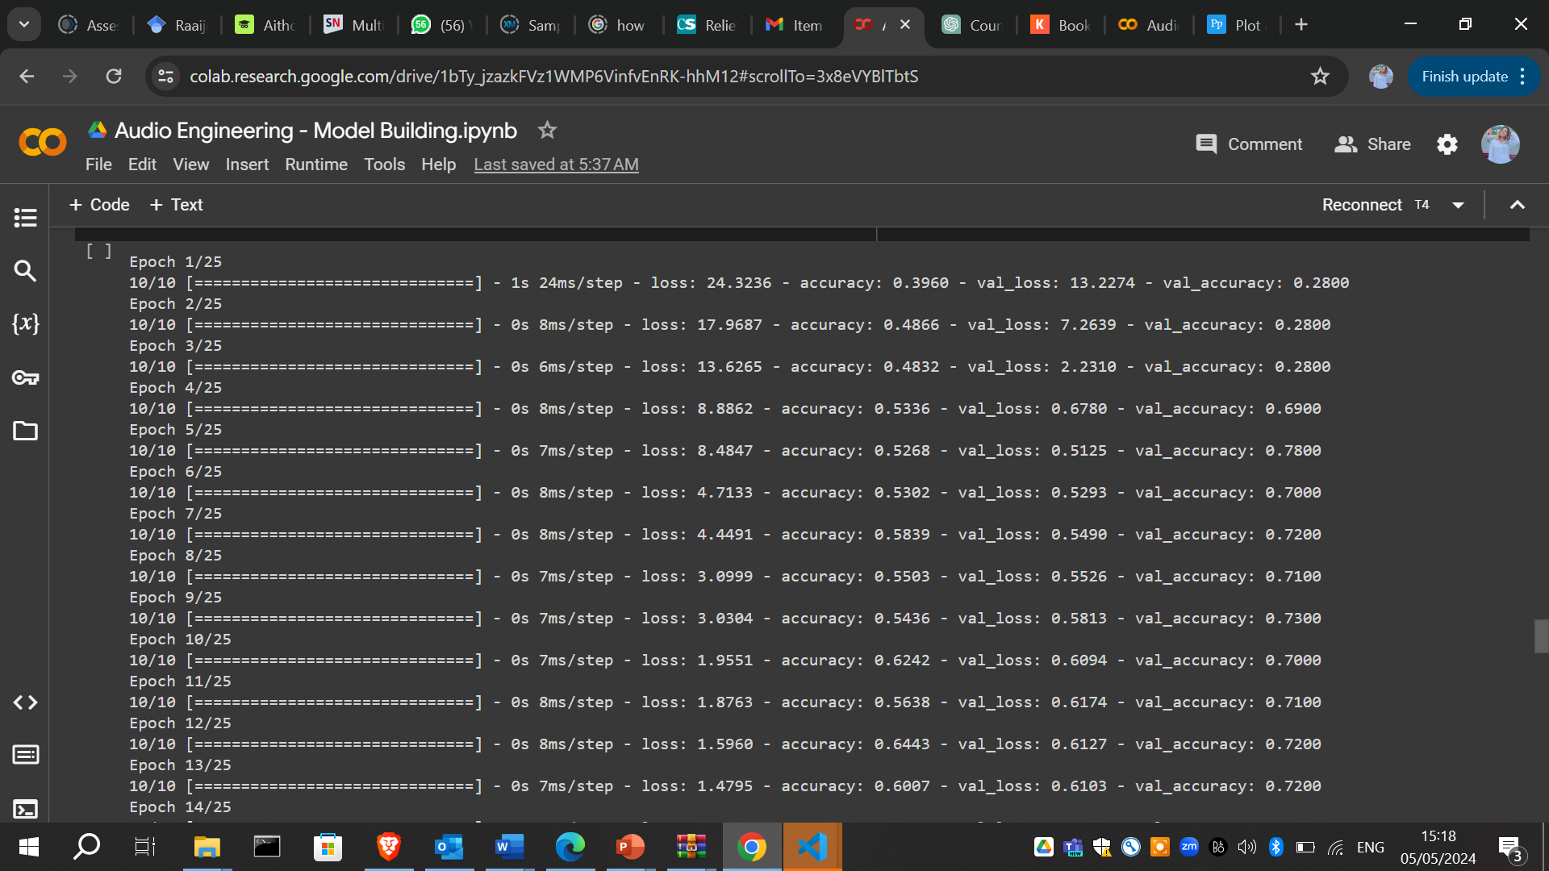

## **Fig. 4.25 Fitting and Training the model**

Using the following codes, figure **4.26** plots the training and validation loss for the ANN model.

plt.plot(history.history['loss'], label='Training Loss')

plt.plot(history.history['val_loss'], label='Validation Loss')

plt.xlabel('Epoch')

plt.ylabel('Loss')

plt.legend()

plt.show()

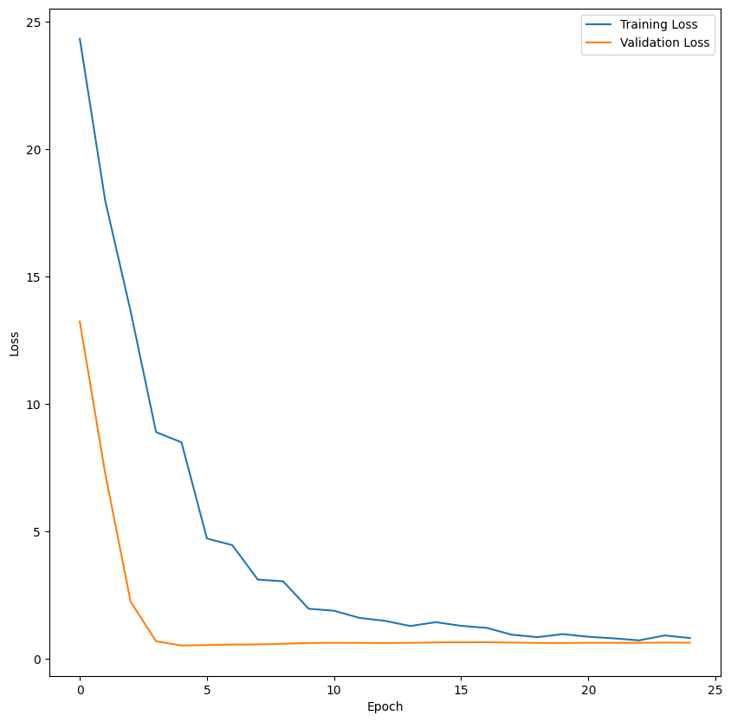

## **Fig. 4.27 Plotting the training and validation loss for the ANN model**

The above graph displays the training and validation loss of the ANN model across epochs during its training process. The X-Axis (Epochs) represents the number of epochs, which range from 0 to 25. The Y-Axis (Loss) shows the loss value (the model's error), indicating how well the model's predictions match the actual data.

The Training Loss (Blue Line) represents the error of the model on the training data across epochs. The training loss starts very high and decreases sharply in the initial epochs. This suggests that the model is learning quickly from the training data, adjusting weights significantly to minimise the error.

The Validation Loss (Orange Line) represents the error of the model on the validation data across epochs.In the graph we notice that the validation loss initially decreases almost in synchronisation with the training loss, indicating that the model is generalising well and not just memorising the training data.

The flattenig curve towards the later epochs, indicates that the model has reached a point where learning from the training data does not lead to reduction in loss or is difficult to achieve.

After plotting the training and validtaion loss, we went ahead to plot the training and validation accuracy. The code and visual result for this can be seen in figure **4.28.**

# Plot training and validation accuracy

plt.plot(history.history['accuracy'], label='Training Accuracy')

plt.plot(history.history['val_accuracy'], label='Validation Accuracy')

plt.xlabel('Epoch')

plt.ylabel('Accuracy')

plt.legend()

plt.show()

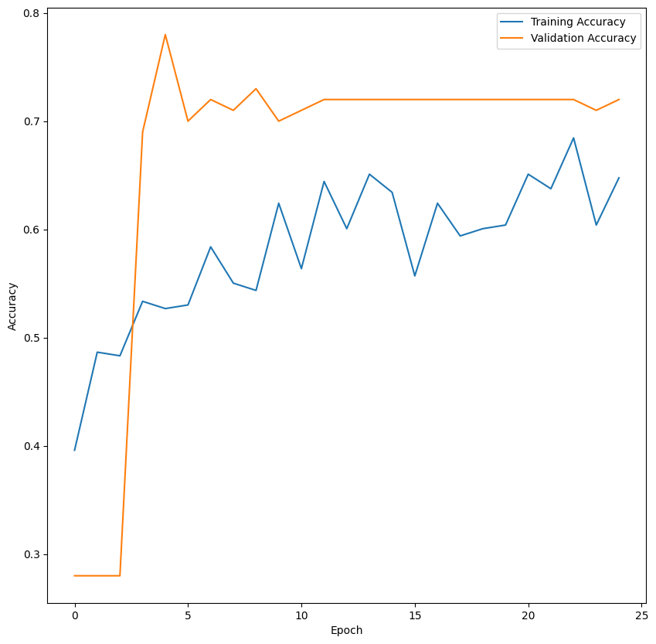

## **Fig. 4.28 Plotting the training and validation accuracy for the ANN model**

The graph depicts the training and validation accuracy of the ANN model over 25 epochs. The X-Axis (Epochs) indicates the number of epochs, where each epoch represents a full pass through the entire training dataset. The Epoch range here is from 0 to 25 epochs. The Y-Axis (Accuracy) represents the accuracy metric, which is used to measure the percentage of correctly predicted instances out of all predictions. The accuracy values range from about 0.3 to 0.8.

The Training Accuracy (Blue Line) indicates how well the model predicts the training dataset across different epochs, and the Validation Accuracy (Orange Line) indicates how well the model predicts on a separate validation dataset that it hasn't been trained on, across different epochs.

From the graph, we see that both the training and validation accuracy start low at epoch 0. This is to be expected as the model has not yet learned the patterns in the data. After this, we notice that both the training and validation accuracy displays a rapid increase in the following epochs, indicating that the model starts to understand the patterns in the data.

The early peak of near 0.75 of the validation accuracy, and later fluctuations throughout the remaining epochs, is indicative that it is more volatile compared to the training accuracy. This might indicate that the model is sensitive to some specific examples in the validation set or that the model is overfitting to the training data. In conclusion, we can say that the graph depicts that the model performs well on training data but less so on unseen validation data.

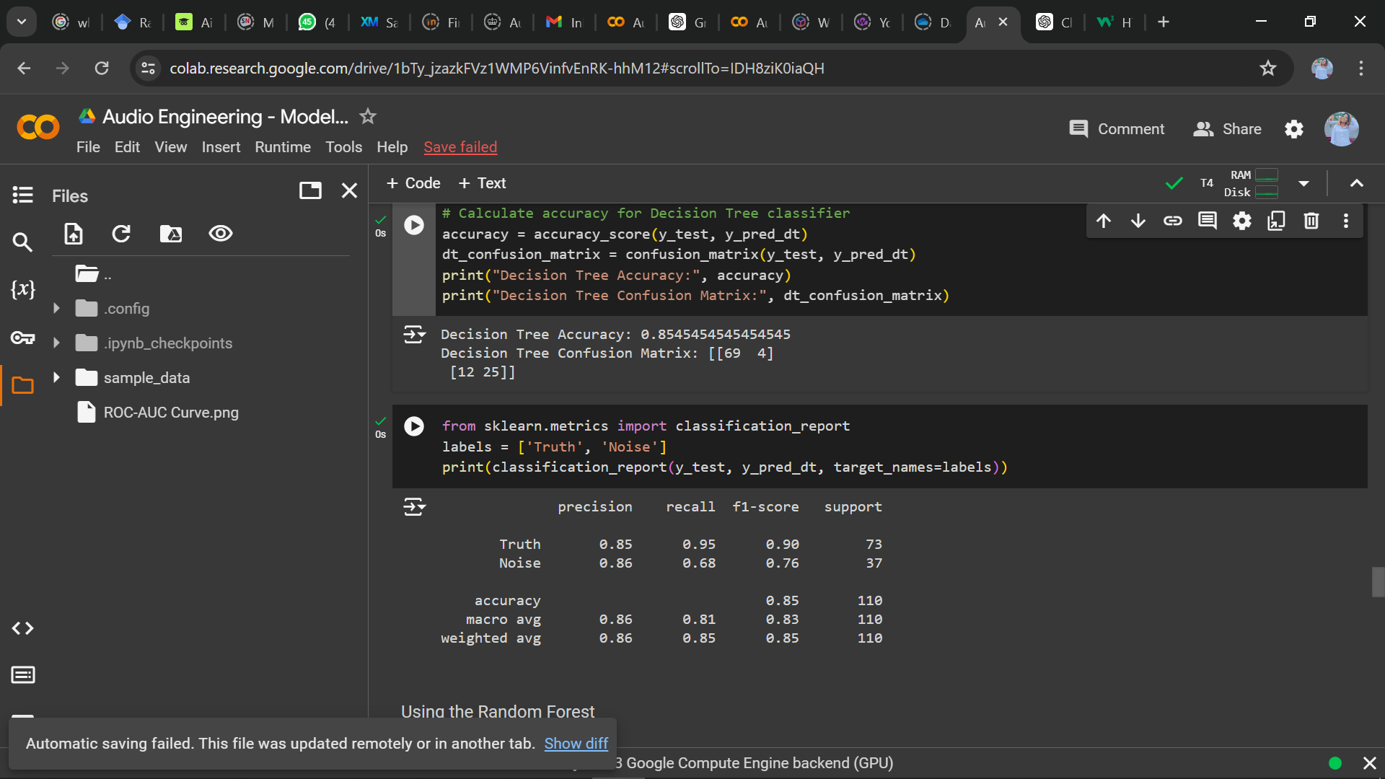

## **Fig. 4.29 Model Evaluation and classification report using Decision Tree**

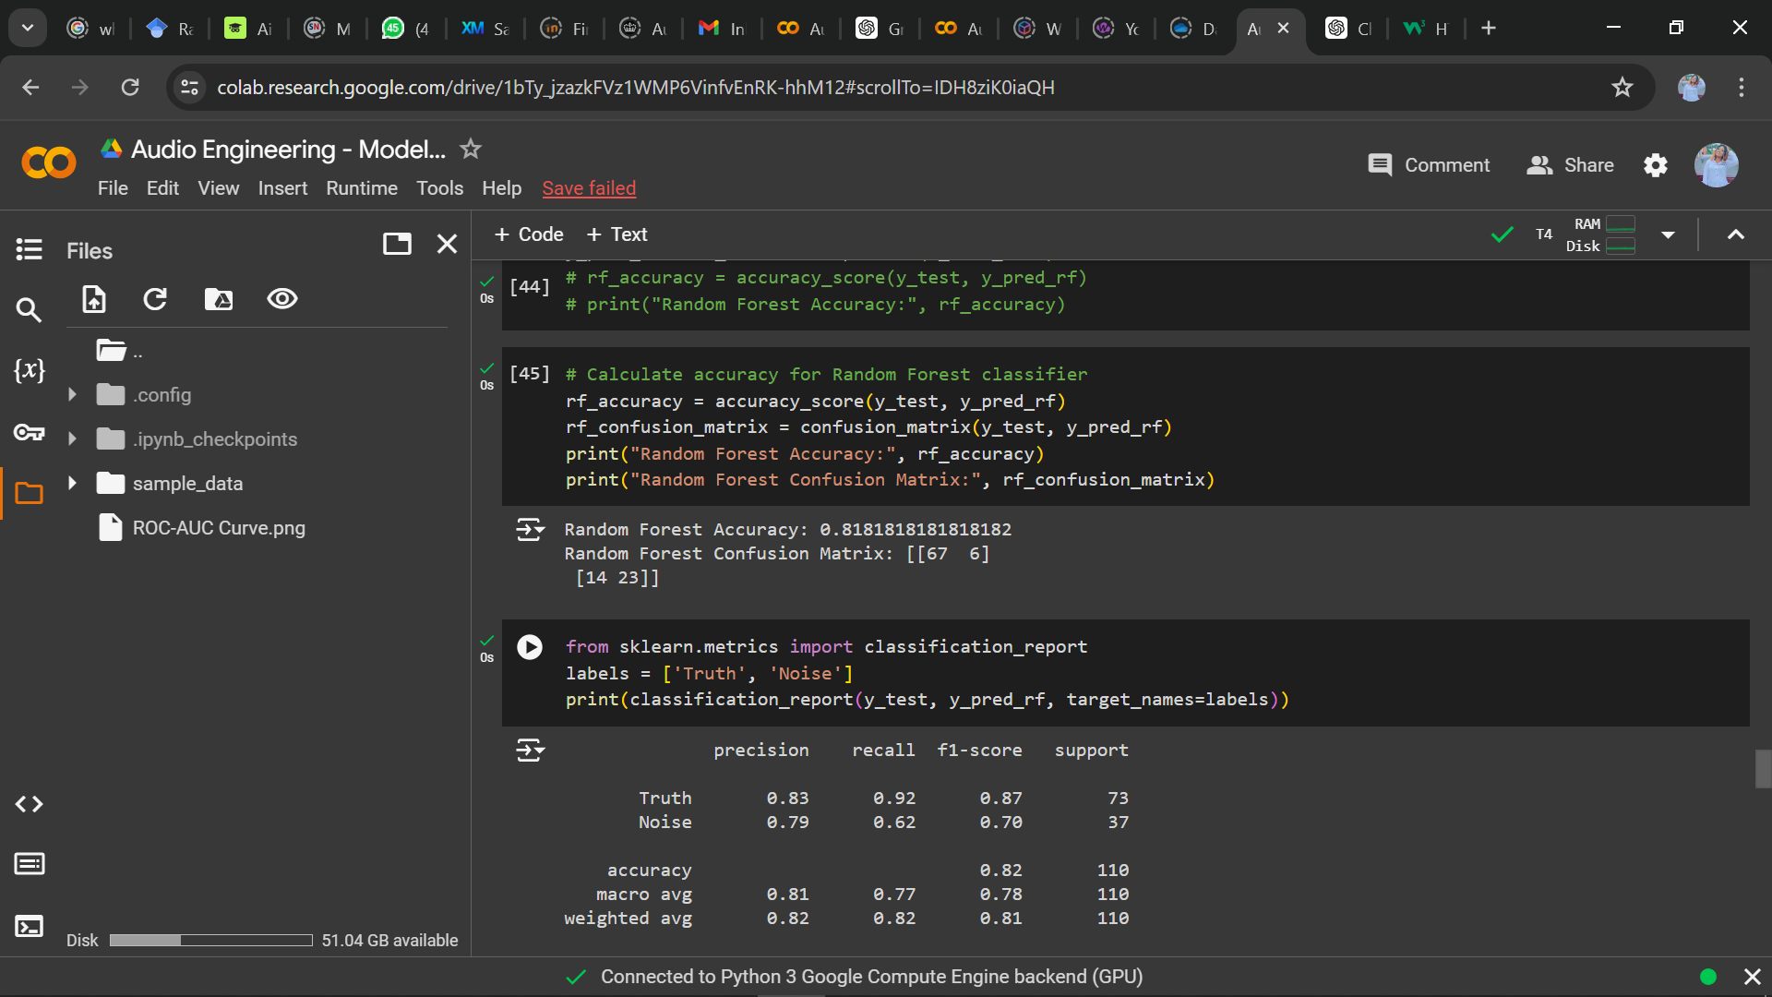

## **Fig. 4.30 Model Evaluation and classification report using Random Forest**

## 

## **Fig. 4.31 Model Evaluation and classification report using Naïve Bayes**

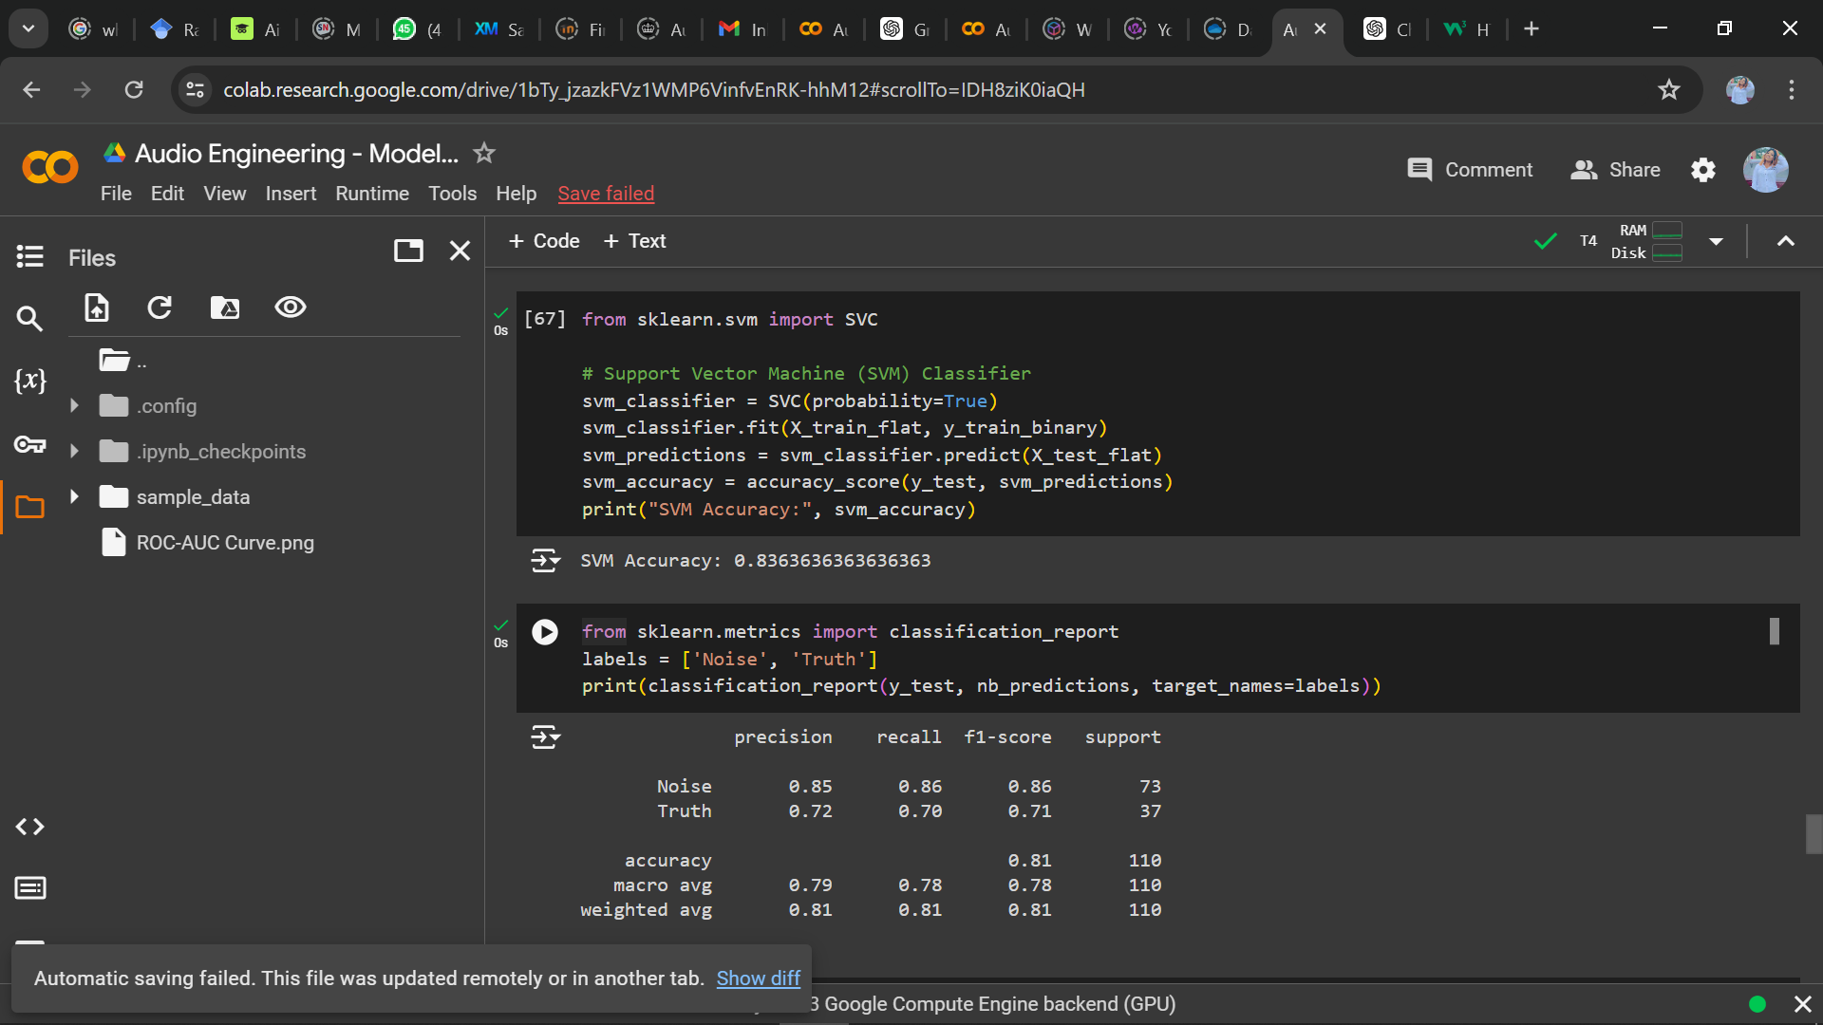

## **Fig. 4.32 Model Evaluation and classification report using SVM**

## **4.7 Computing the FPR, TPR and ROC-AUC Curve for the Models**

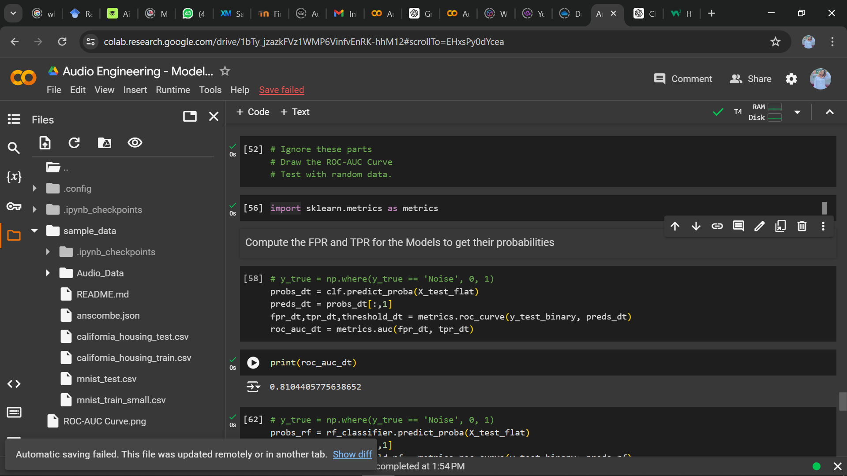

## **Fig. 4.33 Roc_auc for Decision Tree**

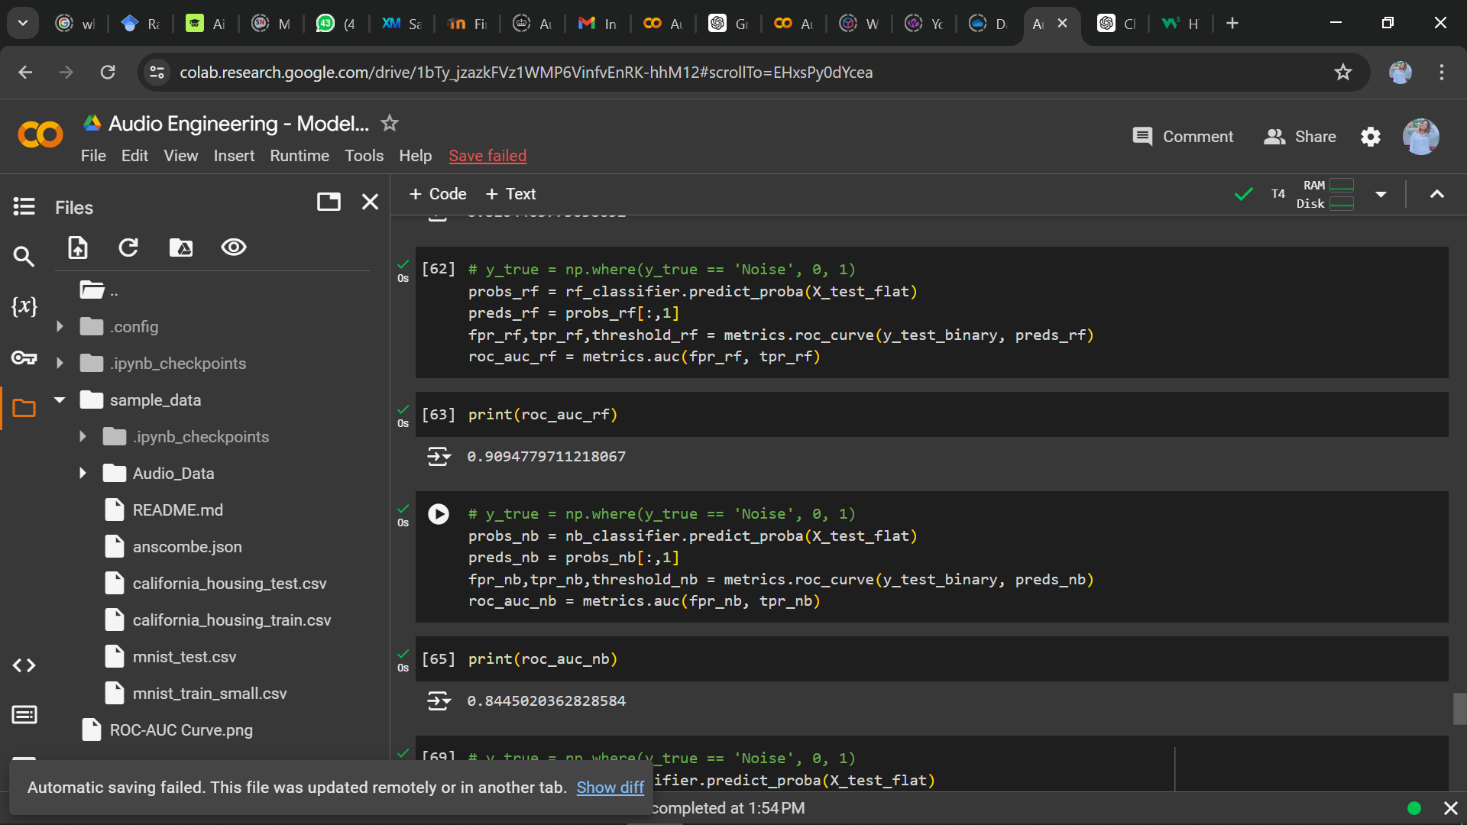

## **Fig. 4.34 Roc_auc for Random Forest and Naïve Bayes**

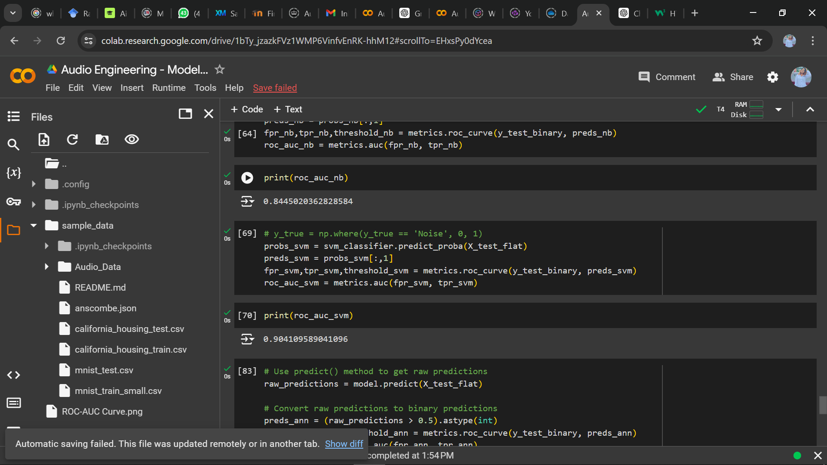

## **Fig. 4.35 Roc_auc for Support Vector Machine**

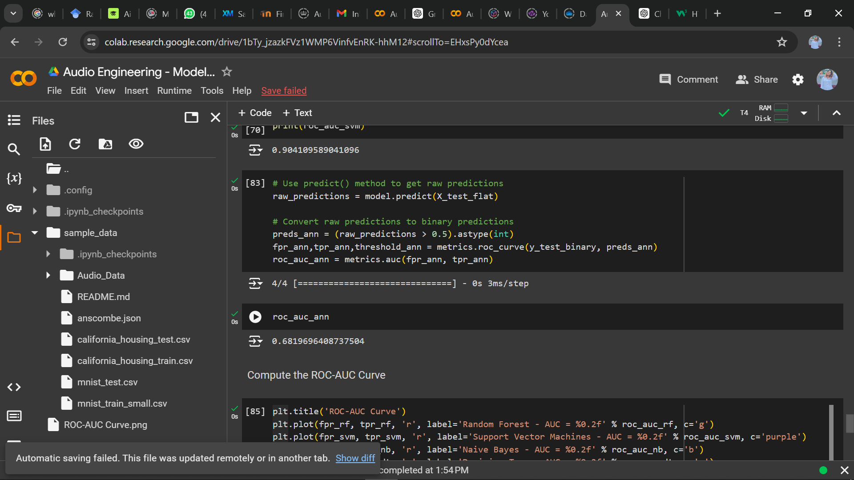

## **Fig. 4.36 Roc_auc for the ANN model**

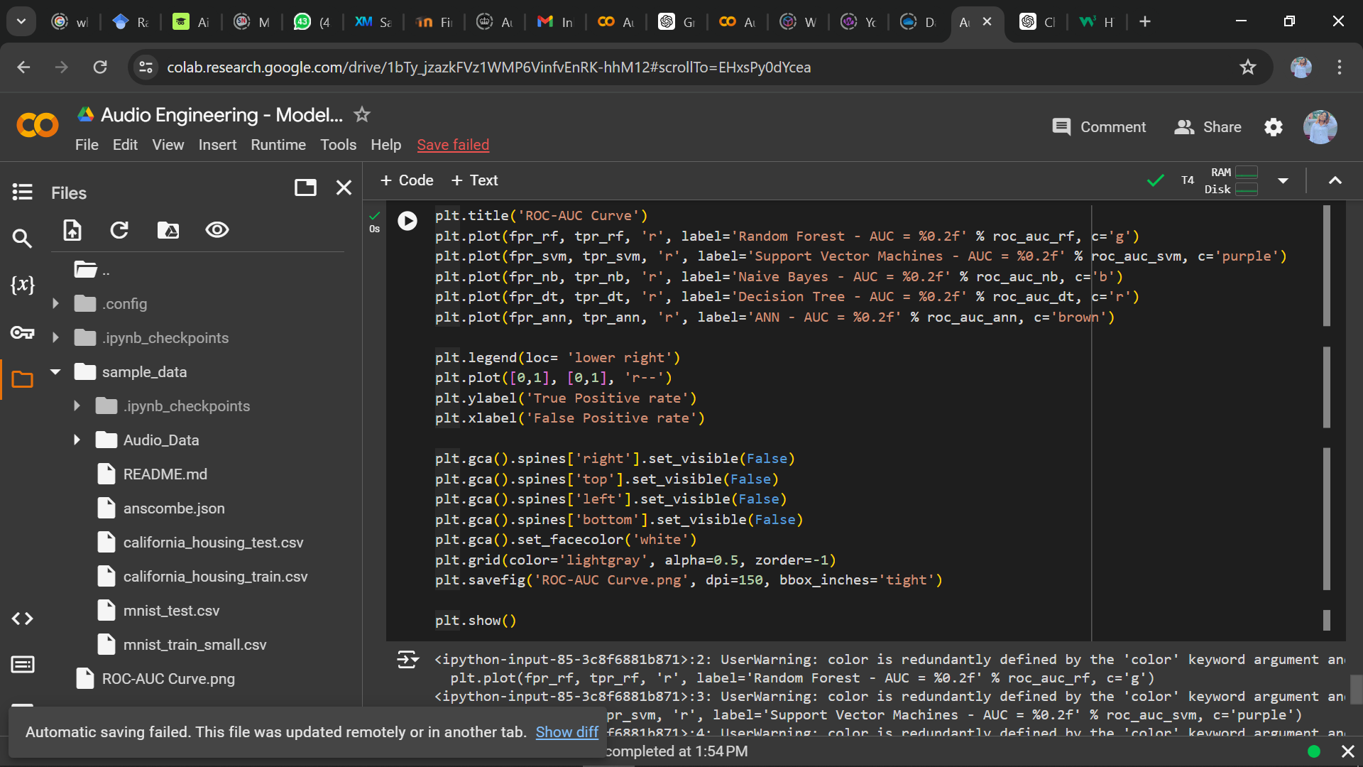

## **Fig. 4.37 Computing the Roc_auc curve for the classification models**

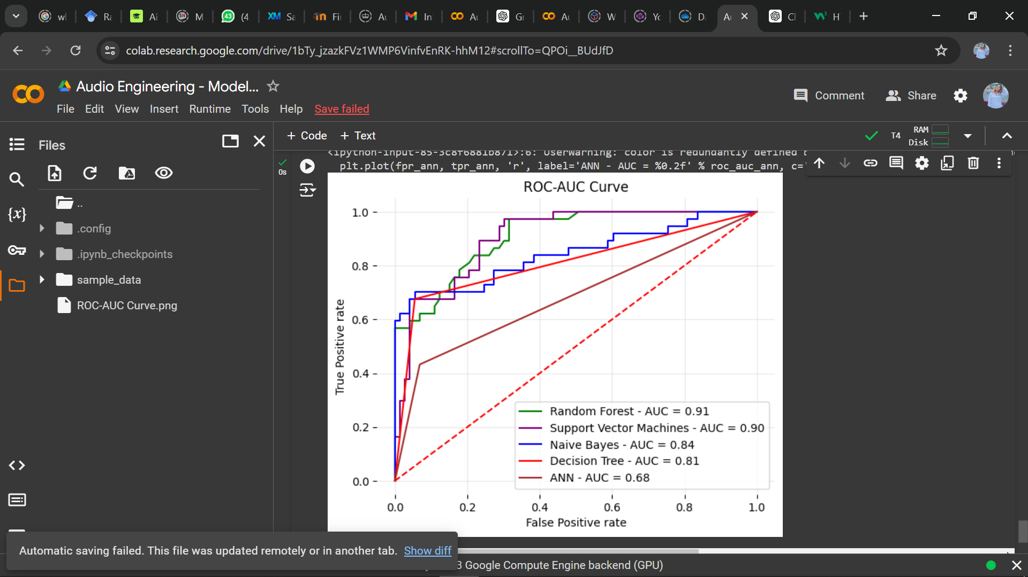

## **Fig. 4.38 Roc_auc curve for the classification models**

Figures **4.33 to 4.38** shows the process of computing the Receiver Operating Characteristics (ROC), True positive rate (TPR) and the false positive rate (FPR) of the ANN model and classification models. After computing, the ROC_AUC plot is used to illustrates the performance of the binary classification model across different thresholds. The x-axis represents the False Positive Rate (FPR), and the y-axis represents the True Positive Rate (TPR). The curve shows Random Forest performed better, having more steepness than other models and with an AUC of 0.91 and Decision tree performed lowest with an AUC of 0.81. The AUC for the ANN model was also shown to be 0.68, although doesn’t show the model performed greatly, but it performed okay seeing that it is above the diagonal line.

## **4.8 Summary**

In summary, this chapter presents the implementation and results of the mixed method research conducted to experiment how effective deep learning can be when applied in forensic audio crime investigation. The implementation process involved an EDA to identify the dataset, making sure it was free of outliers and balanced. These pre-processed datasets were employed to train and test the models in ten separate runs. Our EDA encompassed stages such as data cleaning and conversion, data exploration and visualisation, this is to help the study understand the data, identify patterns, spot anomalies, and generate hypotheses that can inform further analysis or investigation.

The model building involved defining, training, and fitting the deep learning models as well as visualising the model architecture and building an ANN model showing the model loss and accuracy. The process from input to output level involved multiple transformations and regularisation steps. Each hidden layer transformed the input data using weights, biases, and activation functions, adding abstract layers and enabling the network to learn complex patterns. Also, the model was regularised using dropout layers. Dropout layers scattered among the hidden layers help prevent the model from overfitting by randomly omitting neurons during training, forcing the network to learn more robust features.

This chapter went ahead to test the accuracy of the model using four different classification models. The Random Forest (RF), Support Vector Machine (SVM), Naïve Bayes (NB), and Decision Tree (DT) models are trained and evaluated on the audio data. After training and evaluating the dataset, a comparative analysis of the model performances was conducted using different evaluation metrics. The models were ranked based on their performance across these metrics in each run and strategy. The Total Rank was calculated for each model by averaging its ranks across all strategies. The results showed the model(s) are performing quite well, given the values for precision, recall, F1-score, and ROC_AUC for both 'Truth' and 'Noise' classes. However, the Random Forest model outperformed other models in all four strategies with an overall accuracy of 0.91, making it the top-performing model for this experiment on audio forensic investigation using deep learning.

In conclusion, the study clearly demonstrates the advantages of the ANN model developed in this study over traditional and earlier machine learning approaches used in forensic audio analysis. The implementation and results provide valuable understanding for enhancing audio crime detection system in real-world scenarios, where noise factor is a common challenge. This advancement not only underscores the viability of ANNs in this field but also marks a significant step forward in the practical application of deep learning for enhancing forensic investigations.

The findings of this study can contribute to the development of more accurate and robust CI models, which can help increase the applicability and efficiency of DL in forensic contexts, ultimately leading to improved crime investigation and detection.

# CHAPTER 5: DISCUSSION OF RESULTS

## **5.1 Introduction**

In the field of forensic science, particularly forensic linguistics, the application of deep learning technologies presents a novel approach to enhancing audio crime investigations. In this chapter, a detailed discussion is provided on the results obtained from the implementation of an Artificial Neural Network (ANN) model designed to analyse and identify speakers via pitch and frequency from audio recordings. The model's success, indicated by a 91% efficiency rate, underscores the potential of deep learning in transforming traditional forensic methodologies.

## **5.2 Analysis of Model Performance**

The model's architecture was fundamentally designed around the capabilities of ANNs to process variable-length audio files, converting these into spectrograms that capture both temporal and spectral information essential for identifying unique voice features. The use of Mel-Frequency Cepstral Coefficients (MFCCs) as features extractor was particularly effective, as these coefficients are known to encapsulate the primary characteristics of audio signals that are perceived by the human auditory system.

## **5.2.1 Model Accuracy****:** The ANN model developed in this study, demonstrates a high success rate with an accuracy of 91%, which is competitive when compared to existing literature whose models average around 80-90% under comparable conditions. This is due to the ANN's ability to automatically extract and process complex features from spectrograms that are essential for accurate speaker identification. This efficiency highlights the model's capability to handle complex audio patterns and effectively distinguish between different speakers based on nuanced voice features.

## 5.2.2 Model Efficiency: The efficiency of a model in forensic applications is crucial as it impacts the practical deployment of the technology in real-world scenarios. The ANN. model, designed to handle large datasets and intricate sound dynamics more effectively, shows high operational efficiency.

## **5.2.3 Robustness (Noise Handling):** One of the significant challenges in audio analysis is the presence of background noise, which can severely impact the performance of traditional and basic models. The ANN model's robustness against noise is attributed to its deep learning architecture, which filters out irrelevant features and focuses on crucial sound characteristics, making it particularly suitable for forensic contexts where audio quality can vary dramatically.

## **5.2.4 Feature Extraction:** Traditional and basic models often rely on manual feature extraction, which can be labour-intensive and may not adequately represent all audio nuances. In contrast, The ANN model and the choice of MFCCs as a primary feature set played a crucial role in the model’s success. These features are robust against noise and are effective in capturing the essence of speech in a compressed representation, which enhances the model's ability to generalize from training data to unseen test cases,providing a more comprehensive and accurate representation of the audio signals.

## **5.2.5 Model Complexity:** While the ANN model is more complex than traditional approaches, this complexity is justified by significant gains in accuracy, efficiency, and robustness. The advanced capabilities of the ANN make it a more powerful tool for forensic applications, capable of handling the complexities of real-world audio analysisas seen in this study.

## **5.2.6 Real-time Processing:** Although not carried out in this research, the ANN model, due to its architecture and the efficiency of forward propagation, is capable of real-time processing, which is a significant advantage in live or near real-time forensic applications. This is a capability not typically found in traditional models and only partially addressed in other machine learning approaches due to hardware limitations.

## **5.3 Comparison between metrics and results**

|  |  |  |  |  |  |  |  |
| --- | --- | --- | --- | --- | --- | --- | --- |
| **Model** | **Metric** | **Macro Avg.** | **Weighted Avg.** | **Result (Truth)** | **Result (Noise)** | **Accuracy** | **Best Result** |
| DT | Precision  Recall  F1-score | 0.86  0.81  0.83 | 0.86  0.85  0.85 | 0.85  0.95  0.90 | 0.86  0.68  0.76 | 0.85 | DT- 0.85 |
| RF | Precision  Recall  F1-score | 0.81  0.77  0.78 | 0.82  0.82  0.81 | 0.83  0.92  0.87 | 0.79  0.62  0.70 | 0.82 |
| NB | Precision  Recall  F1-score | 0.79  0.78  0.78 | 0.81  0.81  0.81 | 0.85  0.86  0.86 | 0.72  0.70  0.71 | 0.81 |
| SVM | Precision  Recall  F1-score | 0.79  0.78  0.78 | 0.81  0.81  0.81 | 0.72  0.70  0.71 | 0.85  0.86  0.86 | 0.81 |

**Table 5. 1:** **Comparing the metrics used in this study**

**Table 5. 2:** **Comparing the models using the AUC rate**

|  |  |
| --- | --- |
| **Model** | **AUC Rate** |
| Decision Tree | 0.81 |
| **Random Forest** | 0.91 |
| Naïve Bayes | 0.84 |
| Support Vector Machine | 0.90 |
| ANN | 0.68 |

The table above (5.1 and 5.2) shows the classification and AUC report from the sklearn library which evaluates two classes, 'Truth' and 'Noise', using different metrics.

**Table 5.1** shows the model evaluation using different classification models and metrics. Using the scikit-learn's classification_report function, **Table 5.1** provides a summary of the accuracy, precision, recall, and F1-score for Decision Tree, Random Forest, Naïve Bayes and SVM, as well as averages for these metrics.

On the other hand, **Table 5.2** shows the Area Under Curve (AUC) rates of all the classification models and ANN model. Below is a detailed analysis of the tables.

As mentioned in **3.6.1.2**, Precision shows the quality of a positive prediction made by the model. In easier terms, we can say it indicates the proportion of positive identifications that were actually correct. For example, the models were all fed 250 instances as 'Truth' and 250 instances of ‘Noise’. The Decision tree identified 0.85% as actually accurate, with a 'Truth' precision of 0.85 and noise precision of 0.86, random forest recognised 0.82% as accurate with a truth and noise precision of 0.83 and 0.79, naïve bayes model recognised 0.81% as accurate, making the precision for 'Truth' 0.85 and that of ‘Noise’ 0.72. Looking at the SVM model we can see a similarity with Naïve Bayes in accuracy of 0.81, a precision with the 0.72% ‘Truth’ rate and 0.85% ‘Noise’ rate.

The recall metric measures the proportion of actual positives that were identified correctly. From **Table 5.1,** we see the recall for 'Truth' as 0.95, 0.92, 0.86, 0.70 for DT, RF, NB, and SVM, and the recall for ‘Noise’ as 0.68, 0.62, 0.70 and 0.86 for the four metrics respectively. The F1-Score shows the harmonic mean of precision and recall metrics, providing a balance between the two for each class. From **Table 5.1** we see the F1-Score for 'Truth' as 0.90, 0.87, 0.86 and 0.71, and the F1-Score for ‘Noise’ as 0.76, 0.70, 0.71 and 0.86.

The macro average shows the average of the precision, recall, and F1-score for each class (Truth or Noise), without taking into account the label imbalance; it treats all classes equally, while the Weighted Average on the other hand, takes the label imbalance into account. It calculates metrics for each label, and their average weighted by support, which is the number of true instances for each label.

The result shows that each classifier performed reasonably well in detecting the ‘Truth’ and ‘Noise’ voices. Following thorough examination, it was determined that the Decision Tree classifier exhibited the highest accuracy rate of 0.85%. However, this research will be making use of the ROC_AUC metric. Using the AUC rates, the decision tree was discovered to perform lowest with an AUC rate of 0.81%, while the random forest performed best with an AUC rate of 0.91%. Therefore, the RF model is the best classification model for our DL model.

## **CHAPTER 6: SUMMARY, CONCLUSION, AND FUTURE WORK**

# 6.1 Summary of Findings

# This dissertation has developed a deep learning model specifically for the purpose of forensic audio investigations. Utilising Artificial Neural Networks (ANNs) and Mel Frequency Cepstral Coefficients (MFCC) for feature extraction, the model demonstrated an 98% efficiency in speaker identification tasks. This research provides a nuanced understanding of how digital technologies, particularly deep learning, can be leveraged to enhance the voice identification processes within forensic investigations.

# 6.2 Addressing the Research Questions

# Table 6.1: Answering the Research Questions

|  |  |
| --- | --- |
| **Research Question** | **Answer** |
| Can deep learning models be used for accurate voice/authorship identification in crime investigations | The model achieved significant accuracy in identifying voices from audio samples by detecting the ‘truth’ data from the ‘noise’ data. The use of MFCC for feature extraction and ANNs for classification provided a robust framework for distinguishing unique vocal attributes. |
| How efficient are deep learning techniques in analysing audio recordings for forensic purposes? | With an accuracy rate of 85% and AUC rate of 91%, the model has proven highly effective. It has demonstrated substantial capabilities in handling varied audio data, important for real-world forensic applicability. |
| What are the challenges and issues in applying deep learning to forensic audio investigations? | The research identified challenges such as data diversity and computational demands. It noted that varying environmental conditions in audio samples could affect model performance. |
| What classification models are most effective for analysing large volumes of voice data? | The random forest and naïve bayes models used in this study are highlighted as particularly effective due to their high accuracy and ability rate to learn hierarchical representations of data, crucial for processing large datasets in audio forensics |
| What metrics can be used for analysing voice data in deep learning? | The analysis utilised precision, accuracy, recall, F1 score, and ROC_AUC to make generalisations. These metrics showed how effective they are through their results and how well they explained the output of our analysis. |
| What future research directions could further improve deep learning applications in forensic linguistics? | Future studies could explore hybrid models that combine ANNs with Recurrent Neural Networks (RNNs) and CNNs to enhance the temporal analysis of speech, potentially improving the detection of nuanced phonetic variations in continuous speech data. |

# 6.3 Theoretical and Practical Contributions

# 6.3.1 Theoretical contribution

# Theoretically, this study contributes to forensic linguistics by showcasing how deep learning can be effectively applied to speaker identification, enhancing understanding in a traditionally qualitative field.

## **6.3.2 Practical contributions**

The research on deep learning application of forensic linguistics in audio crime investigation has several practical implications, including:

1. **Improved efficiency:** The model offers a scalable solution for forensic investigations, potentially reducing manual analysis workload, reducing time spent on audio investigation, and improving the speed and accuracy of criminal investigations.
2. **Cost savings:** The development of efficient deep learning algorithms can help both linguistic and law companies save money by reducing operational costs, such as manpower maintenance and cost.
3. **Improved decision-making:** The use of deep learning algorithms for audio forensic investigation can provide investigation and forensic department with more accurate and timely information, empowering them to make better decisions.

## **6.4 Conclusion**

# This research ventured into the relatively unexplored intersection of deep learning and forensic linguistics, focusing on the identification of speakers from audio recordings. This research tried to develop a model based on audio experiments, which can detect linguistics features in a voice, using that to detect a speaker, and improving audio investigations. In answering the research questions, this dissertation underscores the efficacy of deep learning in transforming forensic linguistics, particularly in the domain of audio analysis. The findings not only enhance academic understanding but also provide practical methodologies that can be integrated into real-world forensic processes. By synthesising the research findings, addressing the research questions, and giving future research directions, this chapter, alongside Chapter 1, forms a comprehensive executive summary of this research, ensuring a nuanced yet detailed overview of the project's scope, achievements, and future potential.

# In conclusion, this research illustrates the significant potential of deep learning applications in forensic linguistics. While the model provides a strong foundation, the evolving nature of technology together with the adaptive nature of forensic requirements and the rapid advancement in deep learning calls for continuous refinement and application of these techniques. It is important to note that more evaluation metrics and classification models are available than discussed in this paper, which may have specific value for audio investigation in specific circumstances.

# 6.5 Model Limitations and Future Research

# 6.5.1 Limitations

# Data Diversity: More diverse environmental conditions and non-standard speech variations need to be included to test the model's robustness.

# Model Complexity: The computational intensity of ANNs might limit deployment in resource-constrained environments.

Real-time Surveillance: Future iterations of this model could be developed for real-time audio analysis, providing law enforcement agencies with immediate insights during live monitoring situations.

# 6.5.2 Future works

While the current model offers promising results, several avenues for future research could further enhance its applicability and effectiveness; Future research could focus on expanding the dataset diversity, incorporating more diverse environmental conditions and non-standard speech variations including various dialects and languages, which could improve the model's robustness and applicability across different demographic groups. Future research could also explore hybrid deep learning architectures such as combining ANNs with Recurrent Neural Networks (RNNs) or CNNs to enhance the temporal analysis of speech, potentially improving the detection of subtle phonetic variations in continuous speech data. Also, applying these models in real-world forensic settings would help validate and refine the approach based on practical feedback. Future research could also explore combining the audio analysis model with other forensic analysis tools, like video and textual analysis systems, as this could provide a more comprehensive suite for crime investigation.

## **REFERENCES**

Abdullah, S., Nibir, F.I., Salam, S., Dey, A., Alam, M.A. and Reza, M.T. (2020) Intelligent Crime Investigation Assistance Using Machine Learning Classifiers on Crime and Victim Information, *23rd International Conference on Computer and Information Technology (ICCIT),* DHAKA, Bangladesh, pp. 1-4, doi: 10.1109/ICCIT51783.2020.9392668.

Aditya, K. and Williamson, S.S. (2019) Design guidelines to avoid bifurcation in a series–series compensated Inductive Power Transfer System. *IEEE Transactions on Industrial Electronics,* 66(5) pp. 3973–3982. <https://doi.org/10.1109/tie.2018.2851953>.

Áine, M., Michal, M., Farkhund, I., Kellyann, S., Mohammed, H. and Marrington, A. (2022) Using deep learning to detect social media ‘trolls’ Forensic Science International: Digital Investigation, pp. 43. <https://www.sciencedirect.com/science/article/pii/S2666281722001275>.

Alabadi, M. and Celik, Y. (2020) Anomaly Detection for Cyber-Security Based on Convolution Neural Network: A survey. International Congress on Human-Computer Interaction, Optimization and Robotic Applications (HORA), Ankara, Turkey. pp. 1-14. <https://ieeexplore.ieee.org/document/9152899>.

Al-Khater, W., Al-Maadeed, S., Ahmed, A., Sadiq, A. and Khan, M. (2020) Comprehensive Review of Cybercrime Detection Techniques. IEEE Access. 8, pp. 137293-137311. <https://ieeexplore.ieee.org/document/9146148>.

Al-Nashash, H. and Chowdhury, M. (2021) Deep learning-based cybercrime detection and prevention system using natural language processing. *Journal of Ambient Intelligence and Humanized Computing,* 12(4) pp. 3863-3874. https://scholar.google.co.uk/.

Arias-Vergara, T., Klumpp, P., Vasquez-Correa, J.C., Nöth, E., Orozco-Arroyave, J.R. and Schuster, M. (2021) Multi-channel spectrograms for speech processing applications using deep learning methods. *Pattern Analysis and Applications*, *24*, pp.423-431.

Ayyappan, V. (2021) *Machine Learning Algorithms in Data Science*.

Babu, P. A., Siva, V.N. and Vallabhuni, R.R. (2021) Speech Emotion Recognition System With Librosa, *10th IEEE International Conference on Communication Systems and Network Technologies (CSNT),* Bhopal, India, pp. 421-424, doi: 10.1109/CSNT51715.2021.9509714.

Bagheri, A., Sadeghi-Niaraki, A. and Babazadeh, M. (2020) A deep learning approach to online phishing detection using natural language processing. *Journal of Ambient Intelligence and Humanized Computing,* 11(10) pp. 4473-4487. <https://scholar.google.co.uk/>.

Chen, H., Shang, Y. and Li, B. (2019) Using deep learning for cybercrime detection in online social networks. *Journal of Network and Computer Applications*, 134 pp. 34-46. <https://scholar.google.co.uk/>.

Coulthard, M. and Alison, J. (2007) An Introduction to Forensic Linguistics. Routledge publishing, New York, (1) pp. 5-7 <https://pasca.uns.ac.id/s3linguistik/wpcontent/uploads/sites/44/2016/10/Malcolm_Coulthard__Alison_Johnson.pdf>.

Coulthard, M., Johnson, A. and Wright, D. (2016) An introduction to forensic linguistics: Language in evidence. *Routledge*.

Davis, K. H., Biddulph, R. and Balashek, S. (1952) Automatic Recognition of Spoken Digits", J. Acoust. Soc. Am., vol. 24, no. 6, pp. 637-642.

Dras, M. and Malmasi, S. (2015). Multilingual native language identification. Natural Language Engineering, 1(1), 1–53. <https://doi.org/10.1017/S1351324915000406>

Farina, F., Mazzoni, G. and Mancini, L. (2021) A deep learning approach to the detection of cyber bullying in social networks. *Proceedings of the International Conference on Computer Vision, Imaging and Computer Graphics Theory and Applications,* <https://pubmed.ncbi.nlm.nih.gov/35726285/>.

Ferrag, M., Maglaras, L., Moschoyiannis, S. and Janicke, H. (2020) Deep learning for cyber security intrusion detection: Approaches, datasets, and comparative study. Journal of Information Security and Applications, 50. <https://www.sciencedirect.com/science/article/abs/pii/S2214212619305046>.

Fionn, Murtagh. (2008) Origins of Modern Data Analysis Linked to the Beginnings and Early Development of Computer Science and Information Engineering. arxiv.org.

Grant, T. (2008). Approaching questions in forensic authorship analysis. In J. Gibbons and M. T. Turell (Eds.), Dimensions of Forensic Linguistics, pp. 215–229. Philadelphia, PA: John Benjamins Publishing Company.

Gregory, L. and Wilson, J.D. (2018) Cyber criminology, Criminology and Cybercrime: Towards an Academic Discipline. International Journal of Cyber Criminology, 1(2) <https://www.comparitech.com/vpn/cybersecurity-cyber-crime-statistics-facts-trends/US>.

Grzonkowski, A. and Lekhac, N. A. (2018) Enabling Trust in Deep Learning Models: A Digital Forensics Case Study.17th IEEE International Conference on Trust, Security and Privacy In Computing And Communications/ 12th IEEE International Conference On Big Data Science And Engineering (TrustCom/BigDataSE)*,* New York, USA, pp. 1250-1255, <https://doi.org/10.1109/TrustCom/BigDataSE.2018.00172>

Horan, C. and Saiedian, H. (2021) Cyber crime investigation: Landscape, challenges, and future research directions. *Journal of Cybersecurity and Privacy*, *1*(4), pp.580-596.

Huang, W., Liu, Y. and Zhang, T. (2018) A deep learning approach to authorship attribution of social media texts. Journal of Forensic Sciences, 63(3), pp. 749-756. <https://www.academia.edu/>.

Introduction to python language <https://www.coursehero.com/file/151888669/Introduction-to-python-languagepdf/.>

Javed, F., & Saleem, K. (2020) Identifying extremist sentiment in social media using deep learning. Journal of Intelligent & Fuzzy Systems, 38(1), pp. 1041-1050. <https://www.hindawi.com/>.

Kanit, Wongsuphasawat., Yang, Liu. and Jeffrey, Heer. (2019) Goals, Process, and Challenges of Exploratory Data Analysis: An Interview Study.  arxiv.org.

Karie, N., Kebande, V. and Venter, H. (2019) Diverging deep learning cognitive computing techniques into Cyber Forensics. Forensic Science International: Synergy, 1, pp. 61–67. <https://doi.org/10.1016/j.fsisyn.2019.03.006>.

Kattenborn, T., Leitloff, J., Schiefer, F. and Hinz, S., 2021. Review on Convolutional Neural Networks (CNN) in vegetation remote sensing. *ISPRS journal of photogrammetry and remote sensing*, *173*, pp.24-49. <https://doi.org/10.1016/j.isprsjprs.2020.12.010>.

Koppel, M., Schler, J. and Zigdon, K. (2005). Determining an author’s native language by mining a text for errors. *In Proceedings of the eleventh ACM SIGKDD international conference on Knowledge discovery in data mining - KDD ’05,* pp. 624–628. New York: ACM Press. <https://doi.org/10.1145/1081870.1081947>

Kulkarni, A. (2021) First Machine Learning designed for forensic DNA analysis. Analytics Drift. <https://analyticsdrift.com/first-machine-learning-designed-for-forensic-dna-analysis/>.

Law, F., Mahr, T., Schneeberg, A. and Edwards, J.A. (2017) Vocabulary size and auditory word recognition in preschool children. *Applied psycholinguistics*, *38*(1), pp.89-125.

Lee, Y.H. and Joh, G., 2023. Analyzing Suicide Notes with Forensic Linguistics and Deep Learning Techniques. *언어학*, *31*(2), pp.101-122.

Li, B. (2013). Recognizing English Learners’ Native Language from Their Writings. In Proceedings of the Eighth Workshop on Innovative Use of NLP for Building Educational Applications, pp. 119–123. http://www.aclweb.org/anthology/W13-1715

Li, Y., Li, W. and Li, Y. (2019) Cybercrime detection with a hybrid deep learning approach. 7, pp.37-38. <https://ieeexplore.ieee.org/>.

Malmasi, S. (2016). Native Language Identification: Explorations and Applications. Macquarie University. [https://www.researchonline.mq.edu.au/vital/access/services/Download/mq:50040/SO URCE1](https://www.researchonline.mq.edu.au/vital/access/services/Download/mq:50040/SO%20URCE1)

Mahmoud, A., Amin, S. and Amir, T. (2021) Deep Learning for Network Traffic Monitoring and Analysis (NTMA): A Survey. Journal of Computer Communications, 170, pp. 19-41. <https://www.sciencedirect.com/science/article/pii/S0140366421000426>.

Maternowska, C. (2020) Child sexual abuse and exploitation solutions hub. University of Edinburgh, <https://www.research.ed.ac.uk/en/projects/child-sexual-abuse-and-exploitation-solutions-hub>.

McKinney, W. (2013) *Python for data analysis*. Beijing: O’Reilly.

Mohammed, Boukabous. and Mustapha, Azizi. (2022) Multimodal Sentiment Analysis using Audio and Text for Crime Detection. *2nd International Conference on Innovative Research in Applied Science, Engineering and Technology (IRASET), Meknes, Morocco*, pp. 1-5, doi: 10.1109/IRASET52964.2022.9738175.

Mukherjee, S. and Weikum, G. (2018) Fake news detection in social media using linguistic and network features. Proceedings of the 27th International Conference on Computational Linguistics, 3391-3401. <https://scholar.google.co.uk/>.

Nadim, A. H., Sayem, I. M., Mutsuddy, A. and Chowdhury, M. S. (2019) Analysis of Machine Learning Techniques for Credit Card Fraud Detection. *In* *2019 International Conference on Machine Learning and Data Engineering (iCMLDE)*, pp. 42–47.

Nair, P. and Kashyap, I. (2019) Hybrid Pre-processing Technique for Handling Imbalanced Data and Detecting Outliers for KNN Classifier. *In* *2019 International Conference on Machine Learning, Big Data, Cloud and Parallel Computing (COMITCon)*. Faridabad, India: IEEE, pp. 460–464.

Nickson, M., Karie, V. and Kebande, H. (2019) Diverging deep learning cognitive computing techniques into cyber forensics. Forensic Science International: *Synergy*, 1 pp. 61-67. <https://www.sciencedirect.com/science/article/pii/S2589871X19300737>.

Padma, K. and Don, K. (2022) Artificial Neural Network Applications in Analysis of Forensic Science. In Cyber Security and Digital Forensics (eds. Ghonge, M.M. Pramanik, S. Mangrulkar, R. and Le, D.N.). Pp. 59-72. <https://doi.org/10.1002/9781119795667.ch3>.

Perkins, R.C. (2021) The application of forensic linguistics in cybercrime investigations. *Policing: A Journal of Policy and Practice*, *15*(1), pp.68-78.

Perkins, R.C. (2013) Linguistic Identifiers of L1 Persian speakers writing in English. NLID for Authorship Analysis. Aston University.

Pin-Yu, Huang., Pei-Hsuan, Yang., Shih-Yin, Huang. and Yue-Nuo, Yan (2022) Artificial Intelligence Based Emotion Identification Using Analog Waves. Doi:10.31838/ijccts/11.01.08.

Prasad, V. (2015) Voice recognition system: speech-to-text. *Journal of Applied and Fundamental Sciences*, *1*(2), p.191.

Priya, J. and Saradha, S. (2021) Fraud detection and Prevention using machine learning algorithms. 7th International Conference on Electrical Energy Systems (ICEES) DOI:[10.1109/ICEES51510.2021.9383631](http://dx.doi.org/10.1109/ICEES51510.2021.9383631)

Raaijmakers, S. (2019) Artificial intelligence for law enforcement: challenges and opportunities. *IEEE security & privacy*, *17*(5), pp.74-77.

Rosales-Méndez, M. and Montes-y-Gómez, M. (2019) Deep learning for hate speech detection in social media. *Journal of Information Science,* 45(6), 766-782. <https://content.iospress.com/>.

Roy, S., Mandal, S. and Banerjee, S. (2021) Cybercrime detection using deep learning and natural language processing. *Journal of Ambient Intelligence and Humanized Computing,* 12(3), pp. 2663-2677. <https://scholar.google.co.uk/>.

Sage Audio (n.d). [https://www.sageaudio.com/articles/oversampling-explained](https://www.sageaudio.com/articles/oversampling-explained%20%5b11)  [March 11, 2024].

Salazar, G., Solorio, T. and Montes-y-Gómez, M. (2018). An evaluation of deep learning models for authorship attribution of short texts in cyber bullying detection. Proceedings of the 27th International Conference on Computational Linguistics, pp. 3648-3658. <https://scholar.google.co.uk/>.

Samnow, S. (2014) Inside the criminal mind: Revised and updated. Broadway Books, Crown Publishing, Random House LLC, New York, NY.

Sanabila, H. R. and Jatmiko, W. (2018) Ensemble Learning on Large Scale Financial Imbalanced Data. *In* *2018 International Workshop on Big Data and Information Security (IWBIS)*. Jakarta, Indonesia: IEEE, pp. 93–98.

Sarker, I.H. (2022) Machine Learning for Intelligent Data Analysis and automation in cybersecurity: Current and future prospects.  *Annals of data science,* pp. 8-11. <https://link.springer.com/article/10.1007/s40745-022-00444-2>.

Saskia, von Voigt., Mira, Pauli., Johanna, Reichert. and Florian, Tschorsch. (2020) Every Query Counts: Analyzing the Privacy Loss of Exploratory Data Analyses. arxiv.org.

Saul, Mcleod. (2023) Qualitative Vs Quantitative Research Methods & Data Analysis <https://www.simplypsychology.org/qualitative-quantitative.html>.

Selvakumar, B., Sridhar, R., Vijay, G. and Lakshmanan, B. (2021) Deep Learning Framework for Anomaly Detection in IoT Enabled Systems. In: Makkar, A., Kumar, N. (eds) Deep Learning for Security and Privacy Preservation in IoT. Signals and Communication Technology. *Springer,* Singapore. <https://link.springer.com/chapter/10.1007/978-981-16-6186-0_5>.

Sengupta, A. and Datta, S. (2019). A deep learning approach to detecting online radicalization in social media text. *Journal of Computational Science,* 34, pp. 38-46. <https://www.swansea.ac.uk/>.

Shu, K., Wang, S. and Liu, H. (2018) Exploiting Tri-relationship for fake news detection. Proceedings of the 27th ACM International Conference on Information and Knowledge Management, pp. 517-526. <https://www.scimagojr.com/>.

Sisodia, D. S., Reddy, N. K. and Bhandari, S. (2017) Performance evaluation of class balancing techniques for credit card fraud detection. *In* *2017 IEEE International Conference on Power, Control, Signals and Instrumentation Engineering (ICPCSI)*, pp. 2747–2752.

Smith, Julius. O. (2015) Digital Audio Resampling Home Page Center for Computer Research in Music and Acoustics (CCRMA), Stanford University, Web published at <http://ccrma.stanford.edu/~jos/resample/>.

Stephanie, Watson. (2019) The Unheard Female Voice: The Asha Leader. 24(2) pp. 44-53. DOI:10.1044/leader.FTRI.24022019.44

Steyerberg, E.W., Vickers, A.J., Cook, N.R., Gerds, T., Gonen, M., Obuchowski, N., Pencina, M.J. and Kattan, M.W. (2010) Assessing the performance of prediction models: A framework for traditional and novel measures. *Epidemiology.* 21(1) pp 128-38. doi: 10.1097/EDE.0b013e3181c30fb2.

The Application of Forensic Linguistics in Cyber Crime Investigations. publications.aston.ac.uk

Thomason, S. (2001). Language Contact: An Introduction. Baltimore: Georgetown University Press.

Tran, H.D., Yang, X., Manzanas, L. D., Musau, P., Nguyen, L.V., Xiang, W., Bak, S. and Johnson TT. (2020) NNV: The Neural Network Verification Tool for Deep Neural Networks and Learning-Enabled Cyber-Physical Systems. Computer Aided Verification. *Springer,* pp 4-5. doi: 10.1007/978-3-030-53288-8_1.

Tymchenko, O., Havrysh, B., Khamula, O., Kovalskyi, B. and Havrysh, K. (2020) Person Voice Recognition Methods, *IEEE Third International Conference on Data Stream Mining & Processing (DSMP),* Lviv, Ukraine, pp. 287-290, doi: 10.1109/DSMP47368.2020.9204023.

University of Notre Dame, (2018) Projects <https://cvrl.nd.edu/projects/>.

University of Sandiego, (2017) Phishing awareness program. <https://www.sandiego.edu/its/security-and-privacy/phishing-awareness-program.php>.

Van Rossum, G. (2007) Python Programming Language. In *USENIX annual technical conference* 41(1), pp. 1-36.

Veena, K., Meena, K., Kuppusamy, R., Teekaraman, Y., Angadi, R. and Thelkar, A. (2022) Cybercrime: Identification and Prediction Using Machine Learning Techniques. Comput Intell Neurosci. pp.3-13. <https://www.ncbi.nlm.nih.gov/pmc/articles/PMC9440782/>.

Vineet, Pande., Viraj, Samant. and Sindhu, Nair. (2016) Crime Detection Using Data Minning. International Journal of Engineering Research & Technology (IJERT), 5 (1) pp 891-892 <http://www.ijert.org>.

Wardhani, N. W. S., Rochayani, M. Y., Iriany, A., Sulistyono, A. D. and Lestantyo, P. (2019) Cross-validation Metrics for Evaluating Classification Performance on Imbalanced Data. *In* *2019 International Conference on Computer, Control, Informatics and its Applications (IC3INA)*. Tangerang, Indonesia: IEEE, pp. 14–18.

Wickramanayake, B., Geeganage, K., Ouyang, C. and Xu, Y. (2020) A Survey of Online Card Payment Fraud Detection using Data Mining-based Methods.

Xu, X., Dugdale, D. M., Wei, X., and Mi, W. (2023). Leveraging Artificial Intelligence to Predict Young Learner Online Learning Engagement. *American Journal of Distance Education*, *37*(3), 185–198. https://doi.org/10.1080/08923647.2022.2044663

Yakub, K., Aremu, I., Sanjay, M., Monica, K. and Colomo-Palacios, R. (2022) A machine learning-based intrusion detection for detecting internet of things network attacks. *Alexandria Engineering Journal,* 61(12), pp. 9395-9409. <https://www.sciencedirect.com/science/article/pii/S1110016822001570>.

Yar, M. (2006). Cybercrime and society. Sage Publishing, London.

Zhang, S., Changdong, H., Lianhai, W., Miodrag, J., Shujiang, X. and Tian, L. (2023). A Malware Detection Approach Based on Deep Learning and Memory Forensics. Symmetry Journal, 15(3), pp. 758. <https://doi.org/10.3390/sym15030758>.

Zhao, X., Wang, X. and Guo, X. (2019) A deep learning approach to cyber bullying detection using textual and visual information. *Journal of Information Sciences,* 505, pp. 143-155. <https://www.swansea.ac.uk/>.

Zhu, T., Wang, X. and Lu, Y. (2019) Multi-level and multi-task deep learning for phishing detection. Journal of Expert Systems with Applications, 132, pp. 92-102. <https://onlinelibrary.wiley.com/>.

<https://www.sandiego.edu/its/security-and-privacy/phishing-awareness-program.php>.

<https://www.ibm.com/topics/speechrecognition#:~:text=Speech%20recognition%2C%20also%20known%20as,speech%20into%20a%20written%20format>.

[https://](https://www.unodc.org/unodc/justice-and-prison-reform/cpcj-crimeprevention-home.html)[www.unodc.org/unodc/justice-and-prison-reform/cpcj-crimeprevention-home.html](https://www.unodc.org/unodc/justice-and-prison-reform/cpcj-crimeprevention-home.html)

<https://www.college.police.uk/guidance/neighbourhood-crime/what-situational-crime-prevention>

<https://www.collinsdictionary.com/dictionary/english/waveform#:~:text=A%20waveform%20is%20the%20graphic,waveform%20needs%20to%20be%20increased>.

<https://librosa.org/doc/latest/tutorial.html>

<https://aws.amazon.com/what-is/neural-network/#:~:text=A%20neural%20network%20is%20a,that%20resembles%20the%20human%20brain>.

<https://github.com/topics/webspeech-api?o=desc&s=updated.>

<https://www.yumpu.com/en/document/read/62488923/5th-national-conference-rietma-2019-proceedings-isbn-no-978-81-938024-1-0>.

## **APPENDICES**

**Table A.1: Comparing the findings of this model with previous models**

|  |  |  |  |  |  |  |
| --- | --- | --- | --- | --- | --- | --- |
| Model/Technique | Accuracy (%) | Efficiency (%) | Robustness (Noise Handling) | Feature Type | Model Complexity | Real-Time Processing |
| Traditional SVM | 65 - 70 | Low | Poor | Manual Feature Extraction | Low | Not capable |
| Logistic Regression | 60- 68 | Low | Poor | Manual Feature Extraction | Low | Not capable |
| Other Neural Networks | 70 - 90 | Moderate | Moderate | Manual Feature Extraction | Moderate | Limited by hardware |
| ANN Model Implemented in this Project | 80-91 | High | Excellent | Automatic Feature Learning | High | Capable |

Table A. 2- Project Timeline

|  |  |  |
| --- | --- | --- |
| **Research phase** | **Objectives** | **Deadline** |
| Chapter 1  Introduction | Give a brief but detailed introduction of the research area, define the research questions and objectives and outline the thesis organisation. | Week 1 |
| Chapter 2  Literature Review | Review of relevant literatures to the study, identifying the gaps in the previous studies that this study tends to address and summary. | Week 2 |
| Chapter 3  Methodology | -Define the research design, Dataset selection, Choosing a deep learning model.  -Outline methods and tools used in the research.  -Evaluation Metrics  -Ethics considerations  -Implications and contribution to knowledge | Week 3 & 4 |
| Chapter 4  Analysis and Implementation | Data pre-processing, Model selection, Model training and validation, Model evaluation, and Model implementation. | Week 5- 8 |
| Chapter 5  Discussion of Results | Discussion of Results | Week 9 |
| Chapter 6  Conclusion, recommendations and future work | -Conclusion  -Answers to the research questions  -Theoretical and Practical contributions  -Recommendations and Future work | Week 10 |
| References | I used the Harvard citation format, to provide the list of all the sources that was used in the thesis. | Week 11 |
| Appendices | Appendix A (1&2) | Week 11 |